**Analysis Document Austin**

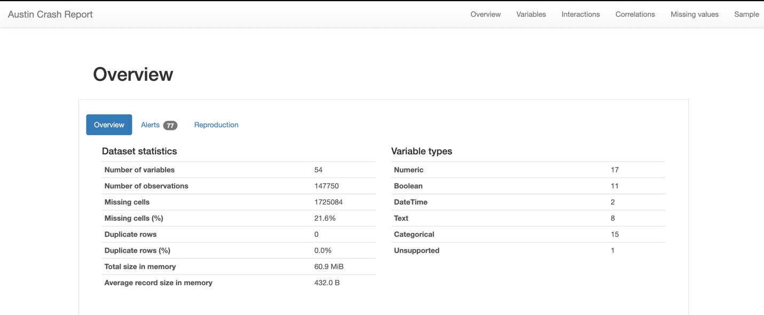

**Dataset Overview:**

* The dataset, labeled as "Austin Crash Report," presumably contains detailed records of vehicle crashes in Austin, with fields capturing various aspects of each incident.
* Each crash is uniquely identified by a crash_id, ensuring no duplicate records and facilitating easy referencing.

**Data Integrity:**

* The dataset appears to be complete regarding crash IDs, as there are no missing values in this field, implying robust data collection and entry methods.

**Location Data:**

* Precise geolocation data is recorded, with rpt_latitude and rpt_longitude for reporting location, as well as latitude and longitude for the crash location.
* This geospatial data can be crucial for mapping accident hotspots and analyzing spatial patterns in crash occurrences.

**Severity and Injury Tracking:**

* The crash_sev_id field likely categorizes the severity of each crash, which is essential for assessing the impact on human health and property.
* Various injury count fields, such as sus_serious_injry_cnt, nonincap_injry_cnt, poss_injry_cnt, non_injry_cnt, and unkn_injry_cnt, provide a detailed breakdown of the injuries' severity, offering insights into the human cost of crashes and highlighting potential areas for safety improvements.

**Speed and Vehicle Data:**

* The crash_speed_limit field could indicate the posted speed limit where the crash occurred, helping to correlate the impact of speed on crash occurrences and severities.
* The absence of significant missing data in key fields suggests a high level of detail, enabling comprehensive analysis of crash factors.

**Contributing Factors:**

* With fields like contrib_factr_p1_id and contrib_factr_p2_id, the dataset likely captures the primary and secondary contributing factors to each crash. This information is vital for identifying common causes and developing targeted prevention strategies.

**Dataset Applications:**

* The data provided can inform traffic safety initiatives, infrastructure planning, and emergency response preparedness.
* Policymakers and city planners can leverage insights derived from this data to implement safety measures, such as traffic calming strategies, educational campaigns, and improved road designs.
* The detailed injury counts could guide healthcare resource allocation to better prepare for the aftermath of road traffic crashes.

**Crash_ID**

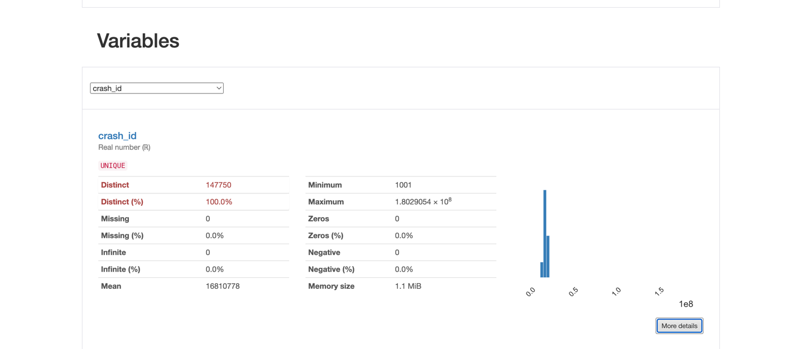

* **Data Completeness:** A significant portion of the ZIP code data, precisely 31.1%, is missing from the dataset. This substantial amount of missing information could potentially hinder analyses that depend on geographic locations, such as spatial distribution of crashes, regional safety evaluations, or infrastructure planning.
* **Distinct Values:** The presence of 235 distinct ZIP codes within the dataset suggests that the data covers a wide range of locations. However, the low distinct percentage (<0.1%) implies that certain ZIP codes are frequently repeated, which could indicate higher incident rates in those areas or a larger population density.
* **Length of ZIP Codes:** The uniform length of ZIP codes, which consistently stands at 5 characters, is in line with the standard format of ZIP codes used in addressing and sorting mail. This consistency is crucial for any form of location-based analysis and ensures standardization in the dataset.
* **Characteristics of Data:**
  1. The dataset utilizes 11 distinct characters, which would typically include the digits 0 through 9. The presence of an additional character may indicate placeholders for missing values or spaces.

**Crash_fatal_fl**

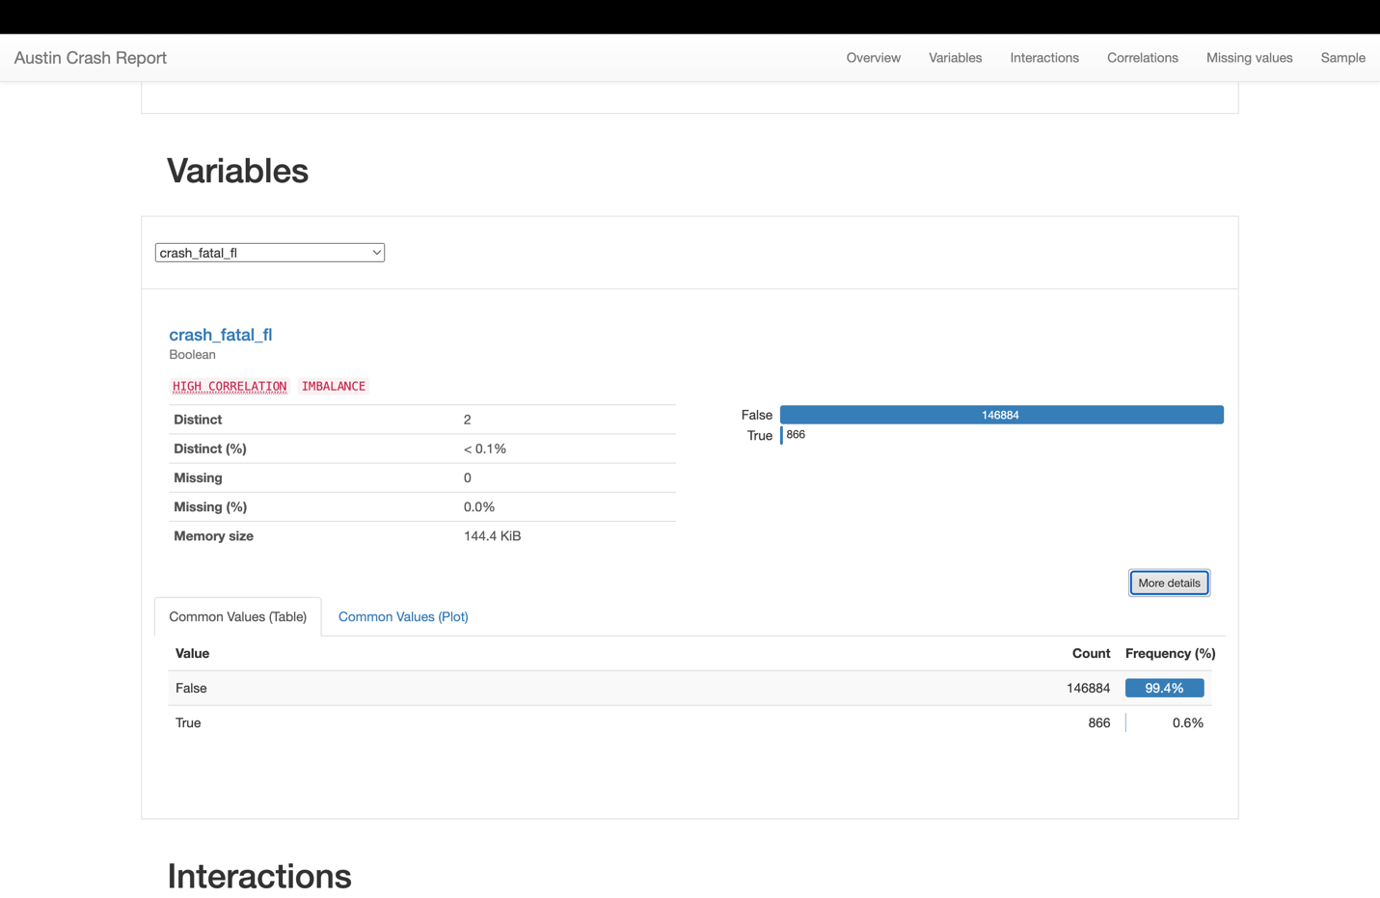

* **Distinct Values:** There are only two distinct values, which corresponds to the Boolean data type – 'True' for a fatal crash and 'False' for a non-fatal crash. The percentage of distinct values is very low (<0.1%), emphasizing the binary nature of this data.
* **Missing Data:** The dataset is complete with 0% missing values for this variable, indicating reliable reporting for the fatality status of crashes.
* **Common Values Distribution:**
  1. False occurrences are overwhelming with 146,884 counts, making up 99.4% of the data. This indicates that the vast majority of reported crashes were not fatal.
  2. True values, indicating fatal crashes, are significantly less with 866 counts, accounting for only 0.6% of the data.

**Crash_date**

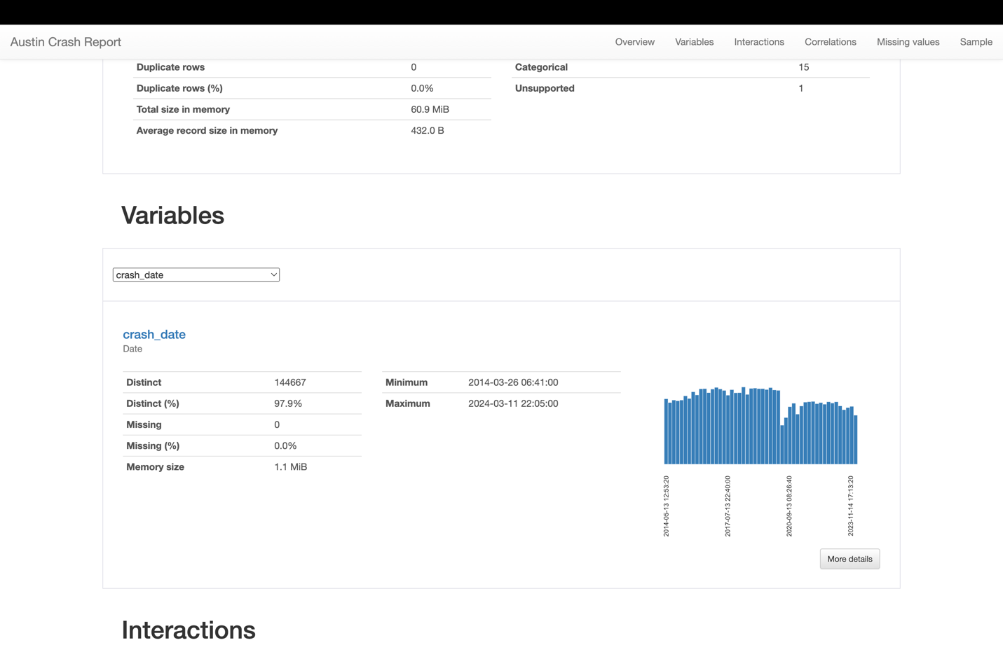

* **Data Completeness:** There is no missing data for the crash_date variable, which implies that all crash reports have a date logged. This comprehensive data is critical for temporal analysis of crashes.
* **Data Range:** The crash dates span from March 26, 2014, to March 11, 2024, offering a decade of data to analyze for trends over time.
* **Distinct Entries:** With 144,667 distinct dates out of 147,750 entries (approximately 97.9%), this suggests that the crashes are distributed across many different days. It also indicates that there are some days with more than one crash recorded.

**Crash_time**

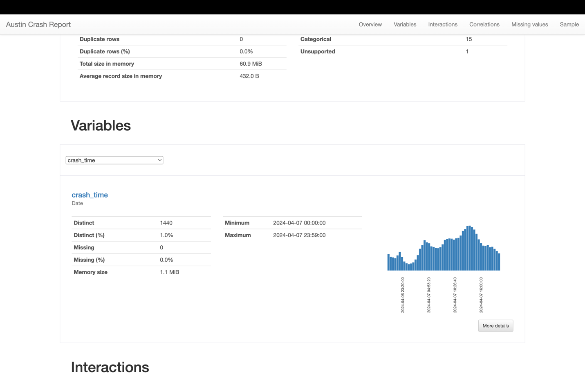

* **Data Completeness:** There is no missing data for the crash_time variable, which means that every crash entry has a time of occurrence recorded. This allows for precise temporal analysis throughout a given day.
* **Data Range:** All the crash_time data entries are from a single day, April 7, 2024, covering the full 24-hour span. This indicates a detailed breakdown of crashes throughout a day.
* **Distinct Entries:** There are 1,440 distinct times which equate to every minute of the day. This granularity shows that the data can pinpoint the time of each crash to the minute, which is beneficial for understanding peak crash times.

**Case_id**

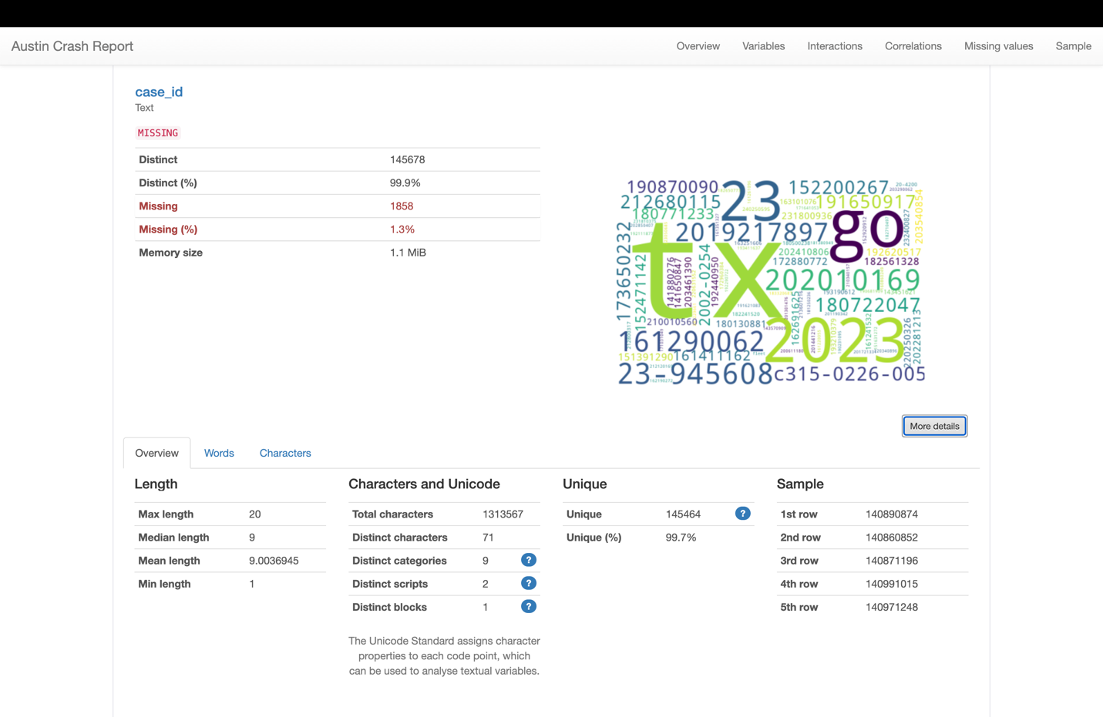

* **Data Completeness:** The dataset is nearly complete, with only 1.3% of the case_id entries missing. This high level of completeness is crucial for ensuring that almost all crash cases can be uniquely identified and referenced.
* **Distinctness:** There are 145,678 distinct case IDs out of 147,536 entries, which indicates a unique identifier for nearly every crash case. This distinctness is vital for differentiating between individual crash events.
* **Memory Efficiency:** Despite the large number of unique identifiers, the data is stored efficiently, with a memory size of just 1.1 MiB.
* **Length of IDs:** The case_id lengths vary, with the longest being 20 characters and the shortest only 1. The mean length is around 9 characters. The variation in length could indicate different formats or types of case IDs, possibly including both numerical and alphanumeric characters.

**Rpt_latitude**

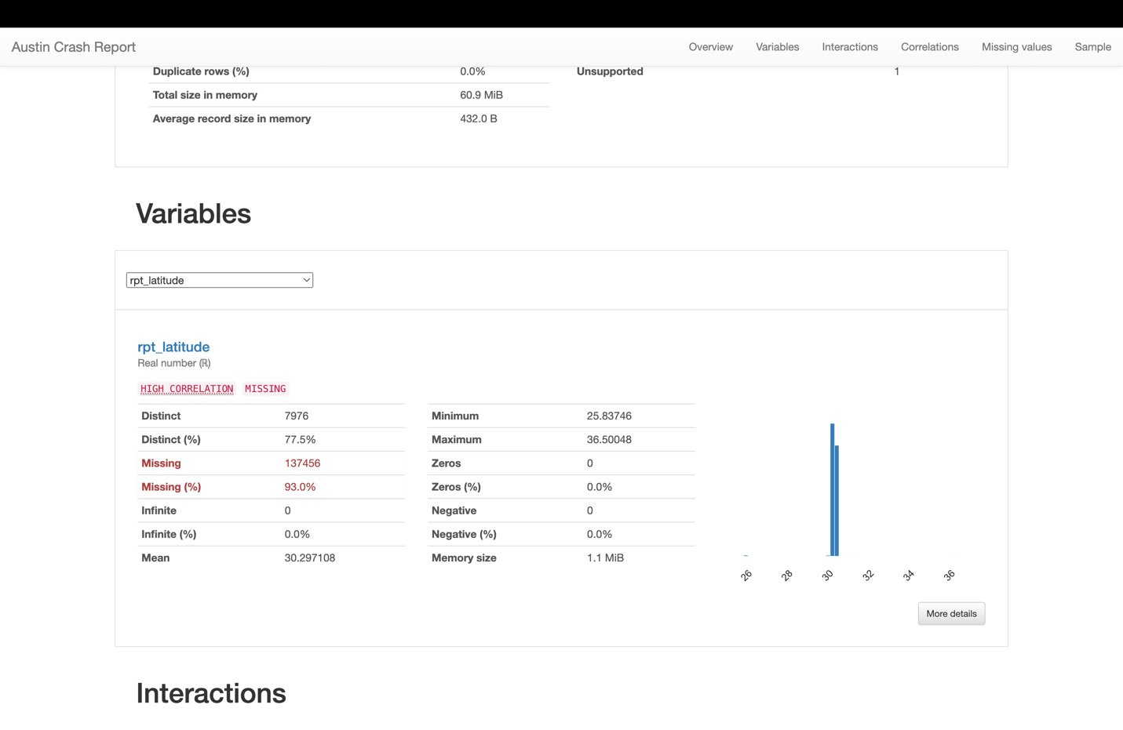

* **Data Completeness:** There is a significant amount of missing data for the rpt_latitude variable, with 93.0% not reported. This presents a considerable gap in the geographic data, which could severely limit location-based analysis and mapping of crash sites.
* **Distinct Latitude Values:** There are 7,976 distinct latitude values present in the dataset, which covers 77.5% of the entries where this data is available. This diversity indicates that the crashes occurred over a wide geographical area.
* **Range of Values:** The latitude values range from 25.83746 to 36.50048. This is a typical range for a large geographical area and could potentially encompass multiple regions or states, suggesting that the report may cover a broad area, or there may be outliers or data entry errors that need to be investigated.
* **Data Integrity:** There are no zeros, negative, or infinite values reported, which implies good data integrity for the entries that are present.
* **Average Value:** The mean latitude is 30.297108, which is a feasible average for a city located in the northern hemisphere and is consistent with the location of Austin, Texas.

**Rpt_longitude**

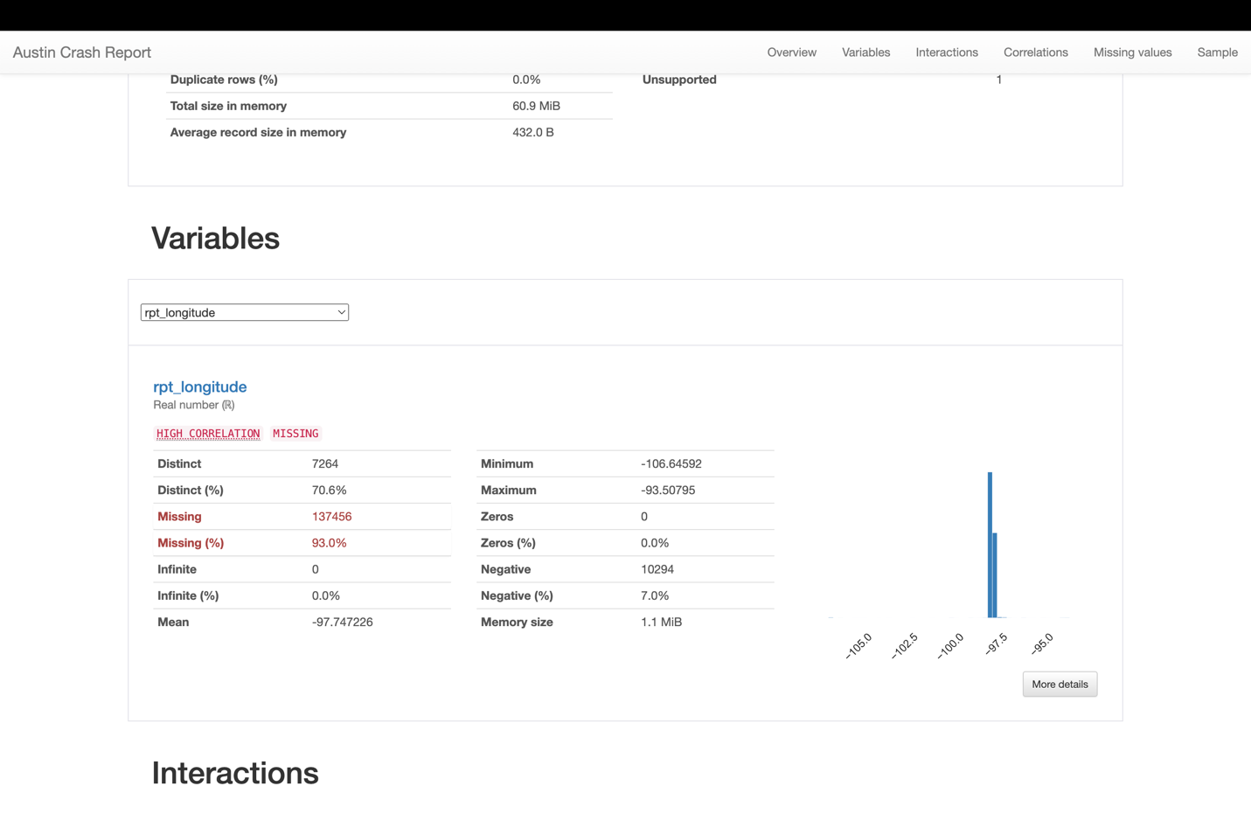

* **Completeness and Integrity:** Much like the latitude data, a substantial portion, 93.0%, of the longitude data is missing, which equally impairs geospatial analysis capabilities. The presence of 7.0% negative values aligns with the geographical location in the Western Hemisphere and indicates no significant data entry issues.
* **Distinct Values:** There are 7,264 unique longitude values, covering 70.6% of the non-missing entries, reflecting a diverse set of crash locations within the reported data.
* **Data Range:** The range of longitude values spans from -106.64592 to -93.50795. This broad range suggests a wide geographical coverage area and indicates that the dataset may include multiple regions within or around Austin, Texas.
* **Average Value:** The mean longitude value is -97.747226, which is a reasonable average for a city like Austin located in Central Texas.

**Rpt_block_num**

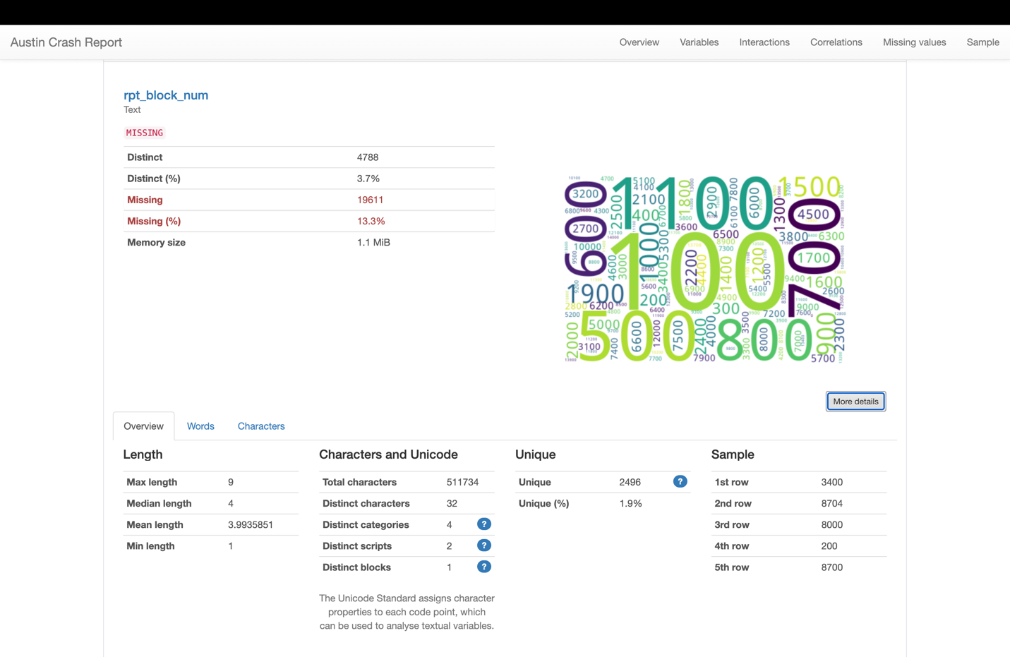

* **Data Completeness:** There is a notable amount of missing data, with 13.3% of the block number entries not reported. While not as high as some other variables, this still represents a significant gap that could impact location-specific analyses and any related policy recommendations.
* **Distinct Values:** The dataset contains 4,788 distinct block numbers, which constitutes about 3.7% distinctness in the non-missing data. This suggests that crashes are spread across many different blocks within the city, providing a good geographical spread for analysis.
* **Data Range and Consistency:** The block numbers have variable lengths, ranging from 1 to 9 characters, with a mean length of approximately 4 characters. This variation is typical as block numbers can vary widely in length.

**Rpt_street_sfx**

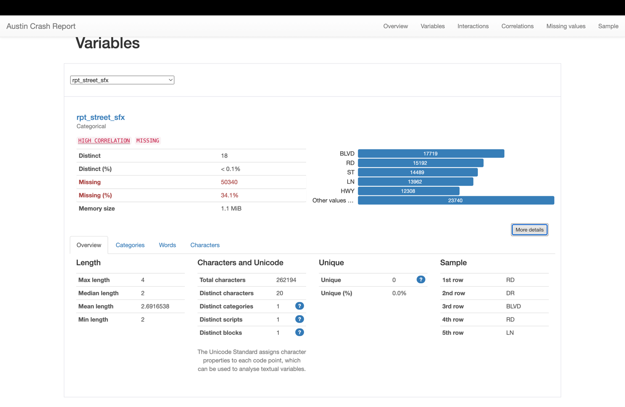

* **Data Completeness:** There is a significant level of data missing, with 34.1% of the street suffix entries not recorded. This poses a limitation in the accuracy of the crash location reports which might be critical for infrastructure planning and risk assessment.
* **Distinct Values:** The dataset records 18 distinct street suffixes, but they account for less than 0.1% of the total entries. This is an expected outcome, as street suffixes such as BLVD, RD, ST, LN, HWY are common and limited in variation.
* **Data Characteristics:**
  1. The street suffixes are generally short, with a mean length of approximately 2 characters and a maximum length of 4 characters, reflecting the standard abbreviation used for street types.
  2. As there is only one category and script listed, this suggests a consistent dataset regarding the type of data (textual), with no additional classifications or foreign language scripts involved.

Crash_speed_limit

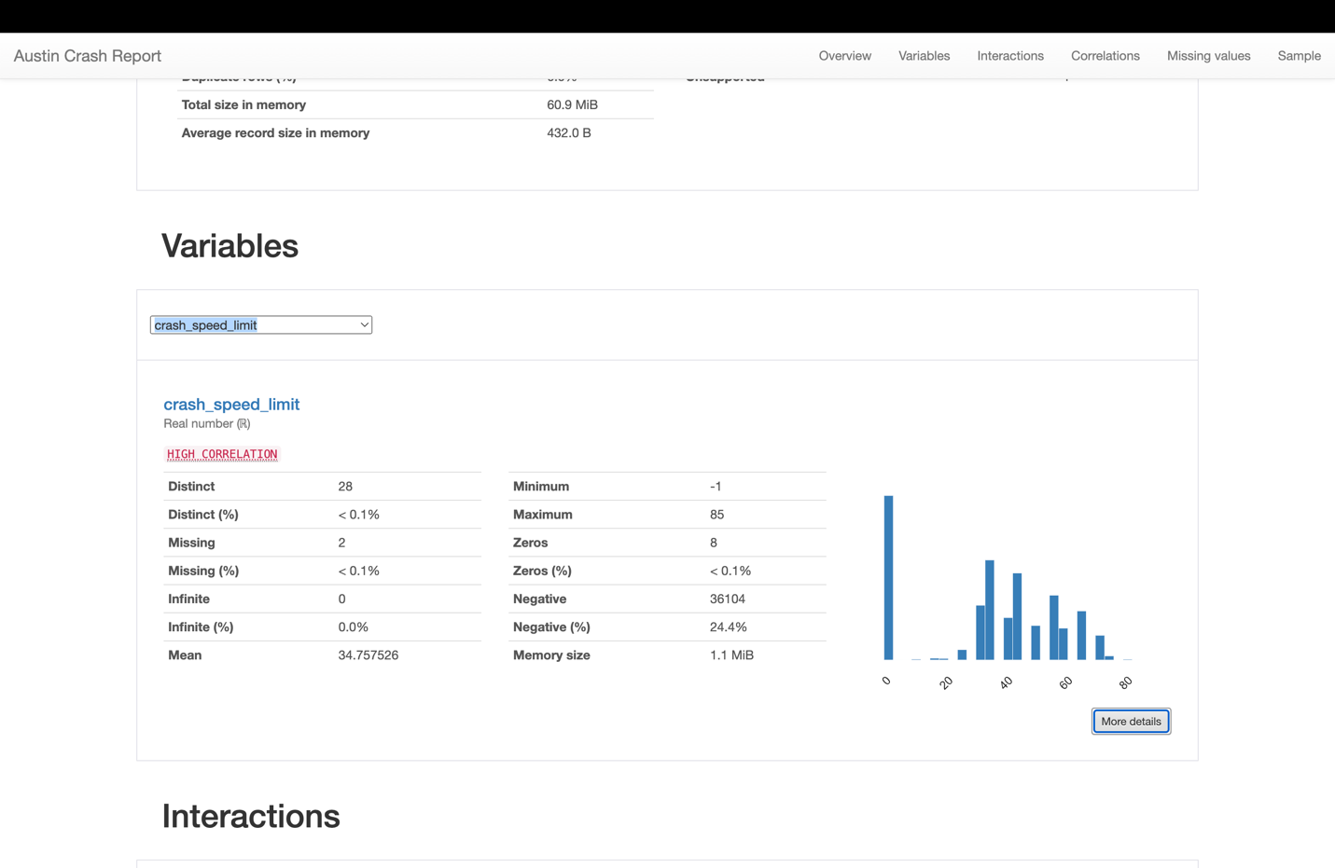

* **Data Completeness:** The data for the speed limit at crash sites is almost complete with only 2 entries missing, which is negligible. This suggests that the speed limit information is generally well-documented in the reports.
* **Distinct Values:** There are 28 distinct speed limits reported in the crashes, which is a reasonable range for urban and rural areas, indicating that crashes occurred under a variety of speed zones.
* **Data Characteristics:**
  1. The presence of a negative speed limit value (-1) is likely indicative of data entry errors or a placeholder for unknown or unposted speed limits. This warrants a review of data collection processes.
  2. The maximum speed limit recorded is 85, which could reflect the highest legal speed limits on some Texas highways.
  3. The mean speed limit is approximately 34.76, which might suggest that many crashes occur in lower speed limit zones, commonly found in urban areas.

**Road_constr_zone_fl**

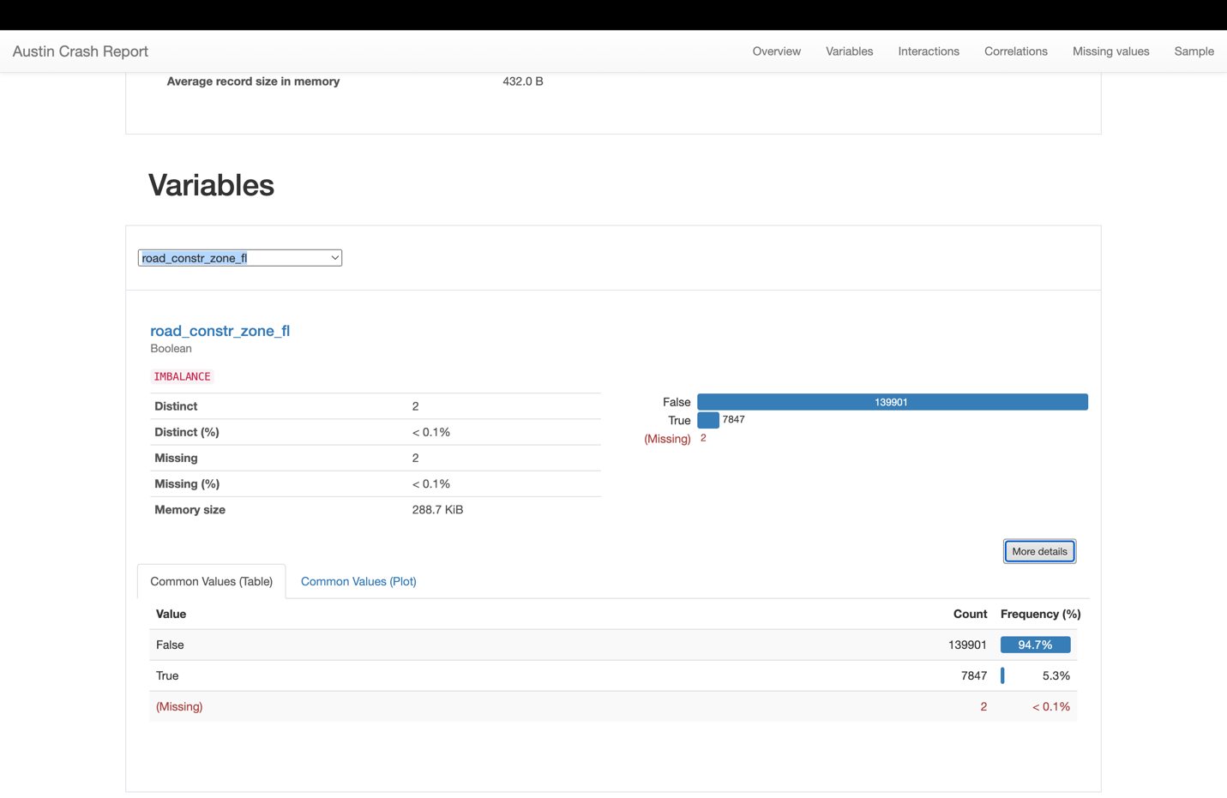

* **Data Completeness:** The road_constr_zone_fl variable has a very high data completeness with only 2 entries missing, indicating reliable data collection for this variable.
* **Value Distribution:** This variable, which appears to indicate whether a crash occurred in a road construction zone (boolean), has two distinct values: True and False. With the vast majority (94.7%) of entries marked as False, this suggests that most crashes did not occur in construction zones.
* **Data Characteristics:**
  1. The imbalance in the distribution indicates that crashes in construction zones are relatively rare compared to other locations, which could be useful for safety analysis and construction zone management.
  2. With such a small number of missing entries, we can be confident in the accuracy of the reporting concerning construction zones.

**Latitude:**

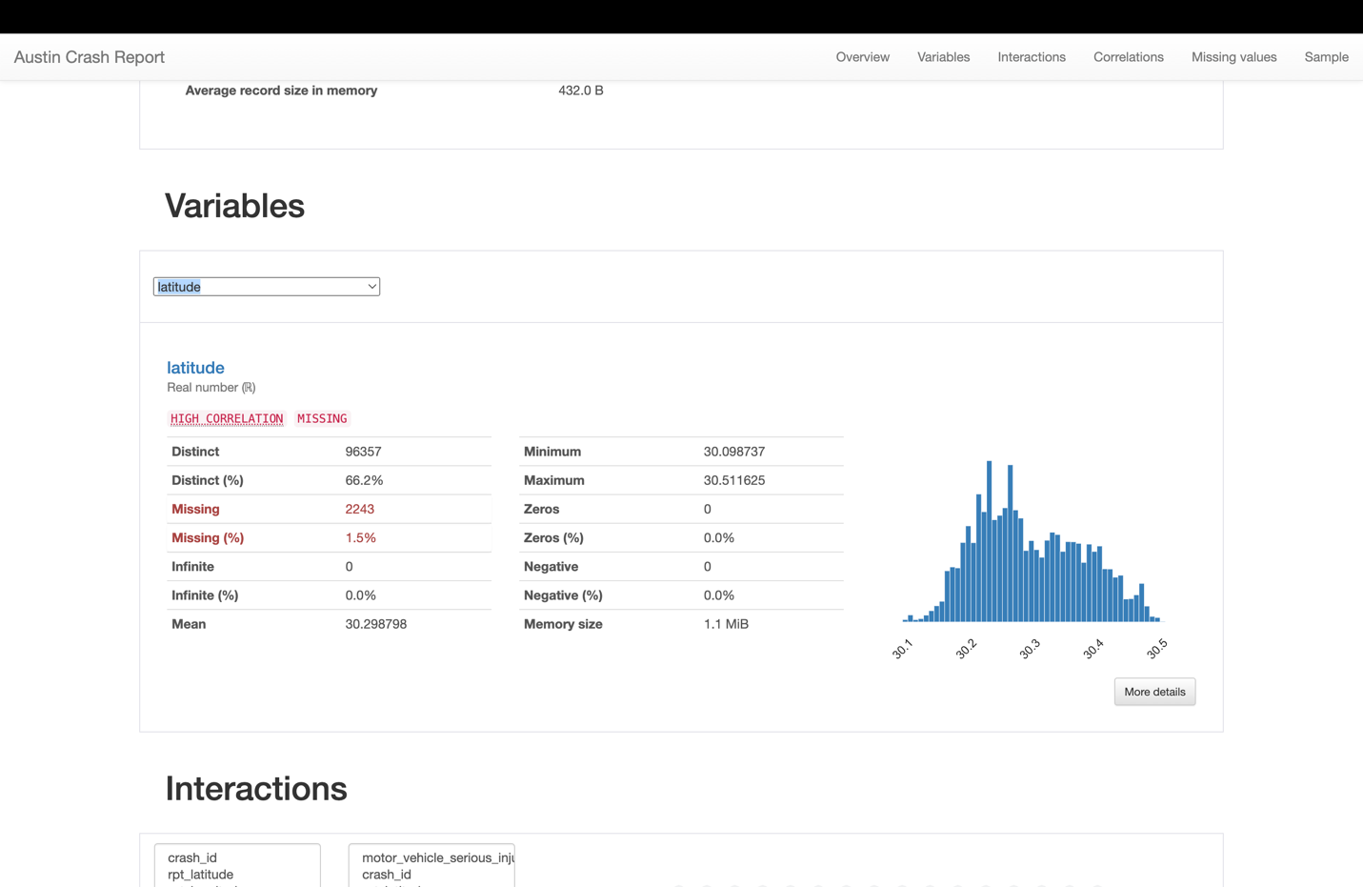

* **Data Completeness:** With 98.5% of data present, the latitude variable offers a comprehensive view for geographical analysis. The missing 1.5% is small enough not to compromise overall data integrity but should still be acknowledged in reporting.
* **Value Distribution:** The latitude values have a normal-like distribution between 30.098737 and 30.511625. This close range of latitude suggests a concentrated area of incident reporting within Austin.
* **Data Characteristics:**
  1. A total of 96,357 distinct latitude readings are reported, indicating a high granularity in the location data, which is valuable for detailed spatial analysis.
  2. The absence of zeros or negative values further validates the appropriateness of the data as latitude readings.

**Longitude:**

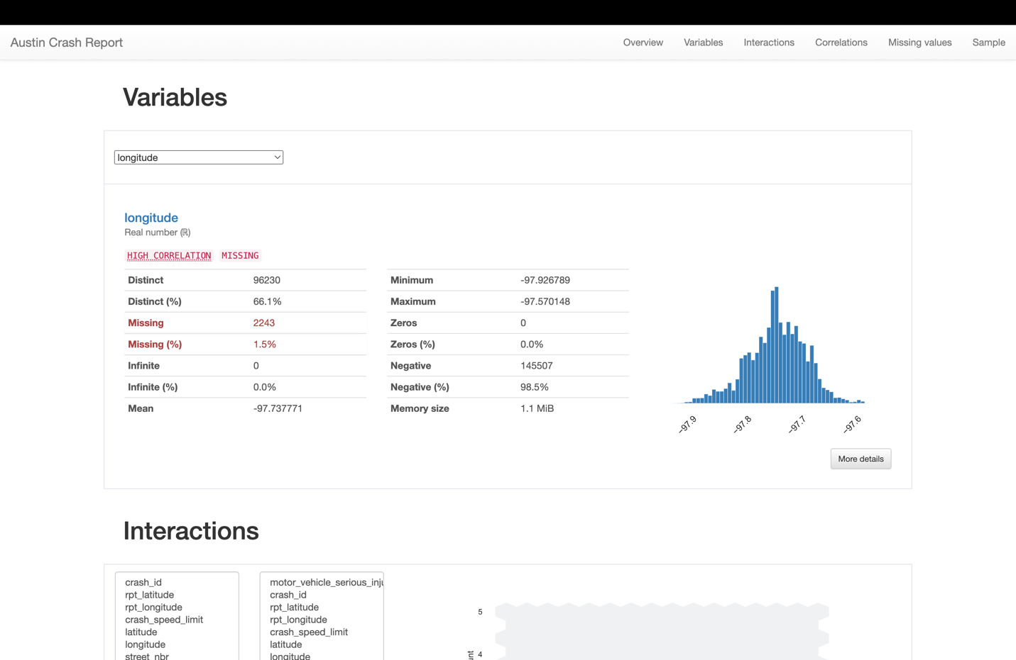

* **Data Completeness:** A total of 98.5% of longitude data is present, indicating a high degree of completeness that allows for reliable longitudinal analysis.
* **Value Distribution:** The longitude variable values range between -97.926789 and -97.570148. The negative values are consistent with the western hemisphere, and the tight range indicates a focused area within Austin.
* **Data Characteristics:**
  1. The data includes 96,230 distinct longitude readings, which, similar to the latitude data, provides high granularity for location-based insights.
  2. All values are negative, as expected for the western hemisphere, with no zero or infinite values, suggesting accurate data entry.

Street_name

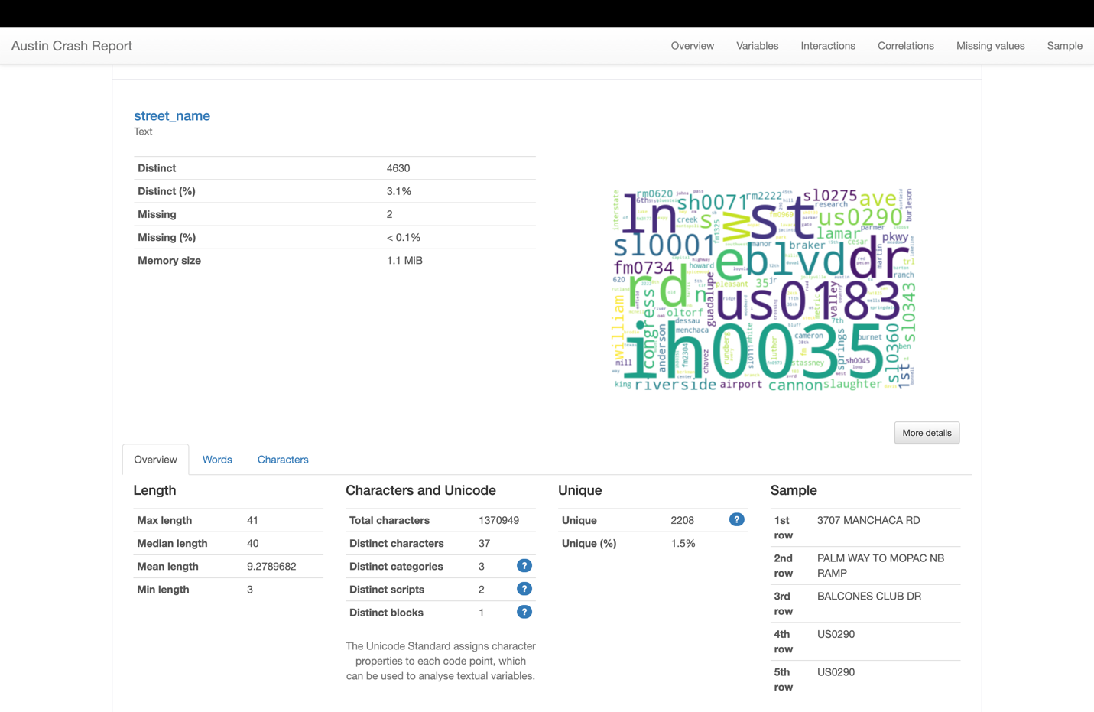

* **Data Completeness:** The dataset has a very high degree of completeness with only 2 missing entries out of a large set, which is less than 0.1%. This suggests that nearly all records have a street name associated with them.
* **Value Distribution:** There are 4,630 distinct street names in the dataset. This diversity indicates a wide distribution of crash locations across numerous streets within Austin.
* **Data Characteristics:**
  1. The length of street names varies, with a maximum length of 41 characters and a mean length of around 9 characters, which is consistent with the varied lengths of street names one would expect in a city.
  2. The dataset uses 37 distinct characters, likely including letters, numbers, spaces, and possibly some special characters like hyphens or periods commonly found in street names.

**Street_nbr**

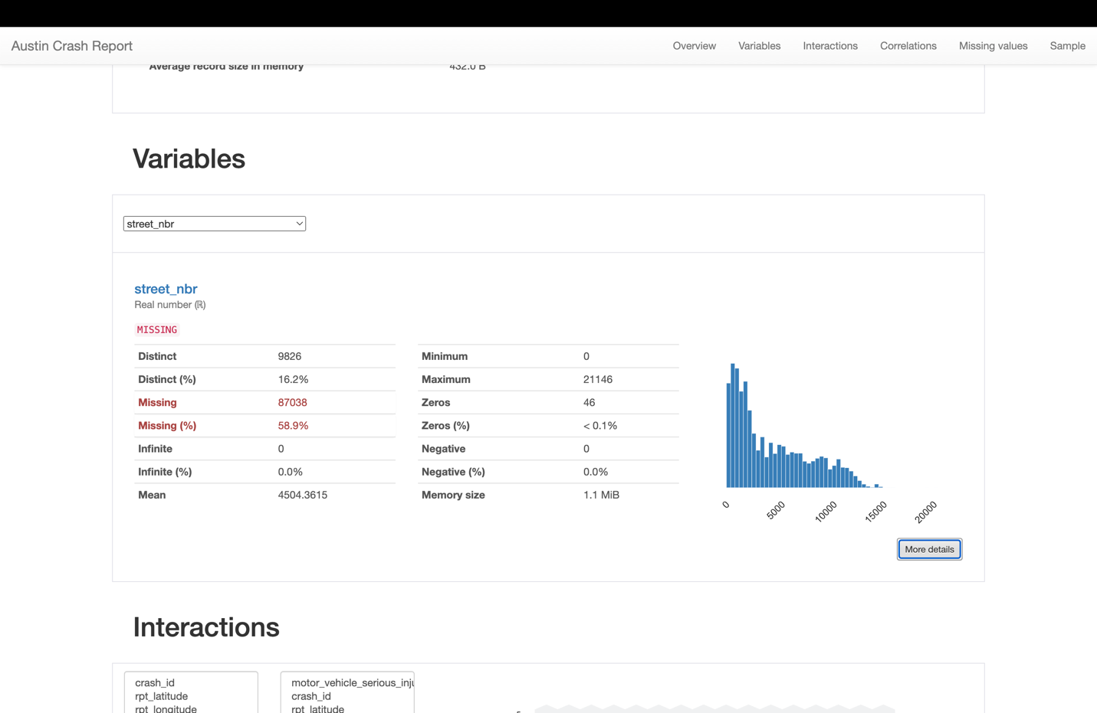

* **Data Completeness:** A significant portion of data is missing (58.9%), which indicates that street numbers for many reports have not been captured or entered. This missing data can have implications for the precision of location-specific analyses.
* **Value Distribution:** The dataset has 9,826 distinct street numbers recorded. This suggests a diverse range of locations for crashes, although the high rate of missing data may mean that the distribution is not fully representative.
* **Data Characteristics:**
  1. The range of street numbers is broad, from 0 to 21,146, which aligns with the variability expected in urban settings.
  2. The presence of 46 zeros may indicate either placeholders for missing data or actual addresses.
  3. The mean street number is 4,504.3615, suggesting that middle-range street numbers are common, although the mean could be influenced by the large amount of missing data.
* **Data Completeness:** A significant portion of data is missing (58.9%), which indicates that street numbers for many reports have not been captured or entered. This missing data can have implications for the precision of location-specific analyses.
* **Value Distribution:** The dataset has 9,826 distinct street numbers recorded. This suggests a diverse range of locations for crashes, although the high rate of missing data may mean that the distribution is not fully representative.
* **Data Characteristics:**
  1. The range of street numbers is broad, from 0 to 21,146, which aligns with the variability expected in urban settings.
  2. The presence of 46 zeros may indicate either placeholders for missing data or actual addresses.
  3. The mean street number is 4,504.3615, suggesting that middle-range street numbers are common, although the mean could be influenced by the large amount of missing data.

**Street_name_2**

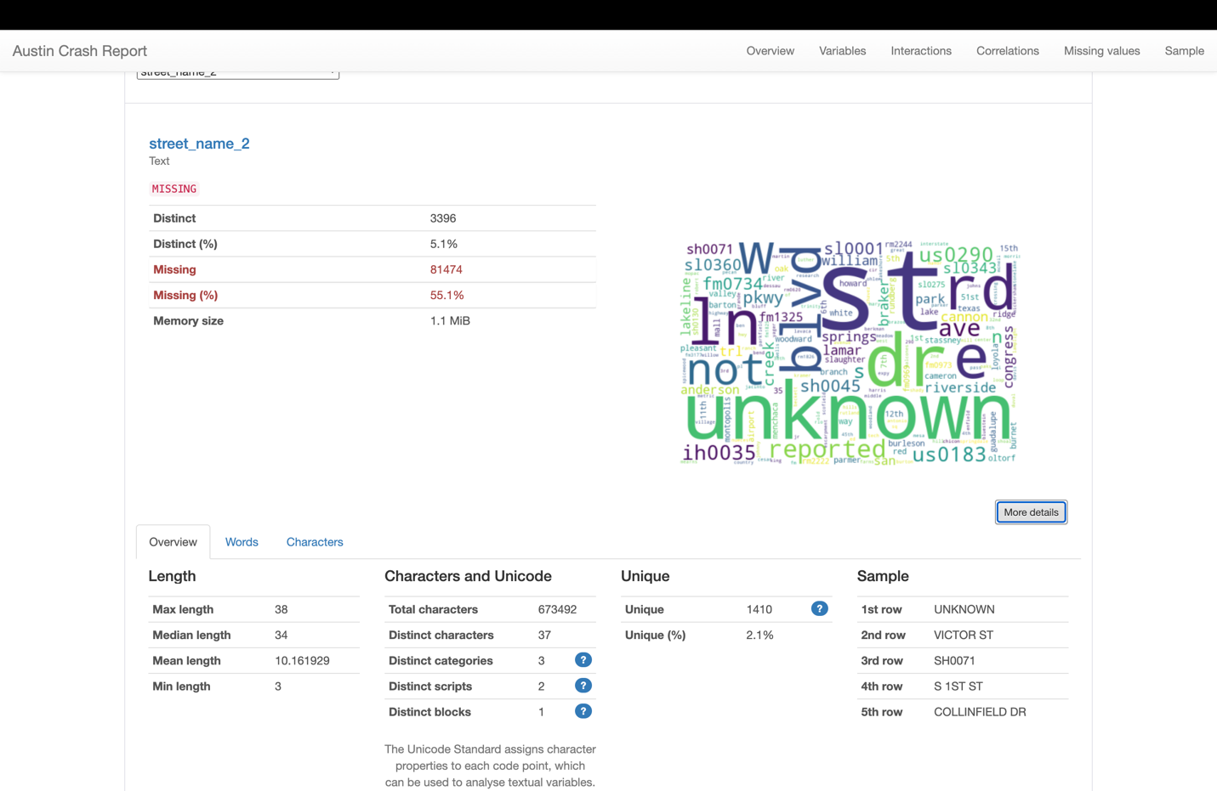

* **Data Completeness:** A significant portion of data is missing (55.1%), indicating that for more than half of the crash reports, the secondary street name is not recorded. This could affect the granularity of location-based analysis and the identification of specific crash sites or patterns at intersections.
* **Value Distribution:** The dataset contains 3,396 distinct secondary street names. This indicates a high diversity of crash locations at or near intersections or where streets have multiple names.
* **Data Characteristics:**
  1. The maximum and median lengths of the street names indicate that they are mostly fully spelled out rather than abbreviated.
  2. The presence of numerous distinct characters suggests that the street names include a variety of naming conventions and potentially include alphanumeric characters.

**Crash_sev_id**

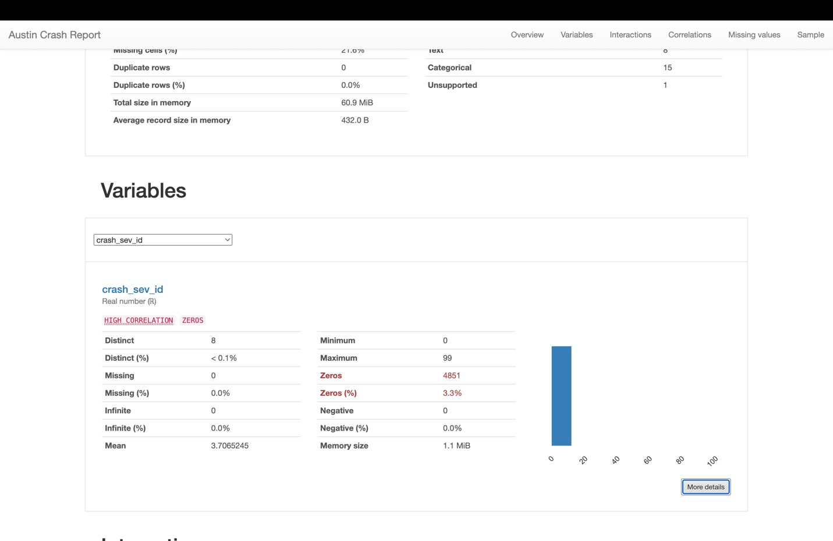

* **Distinct Count and Percentage:** The variable street_name_2 contains 3,396 unique entries which account for 5.1% of all the data points. This variety suggests a broad range of secondary streets involved in crash reports.
* **Data Completeness:** A significant portion of the data, 55.1%, is missing. This high percentage of missing values could pose challenges for analyses that require comprehensive street information, such as detailed location analysis for traffic safety measures.

**Sus_serious_injry_cnt**

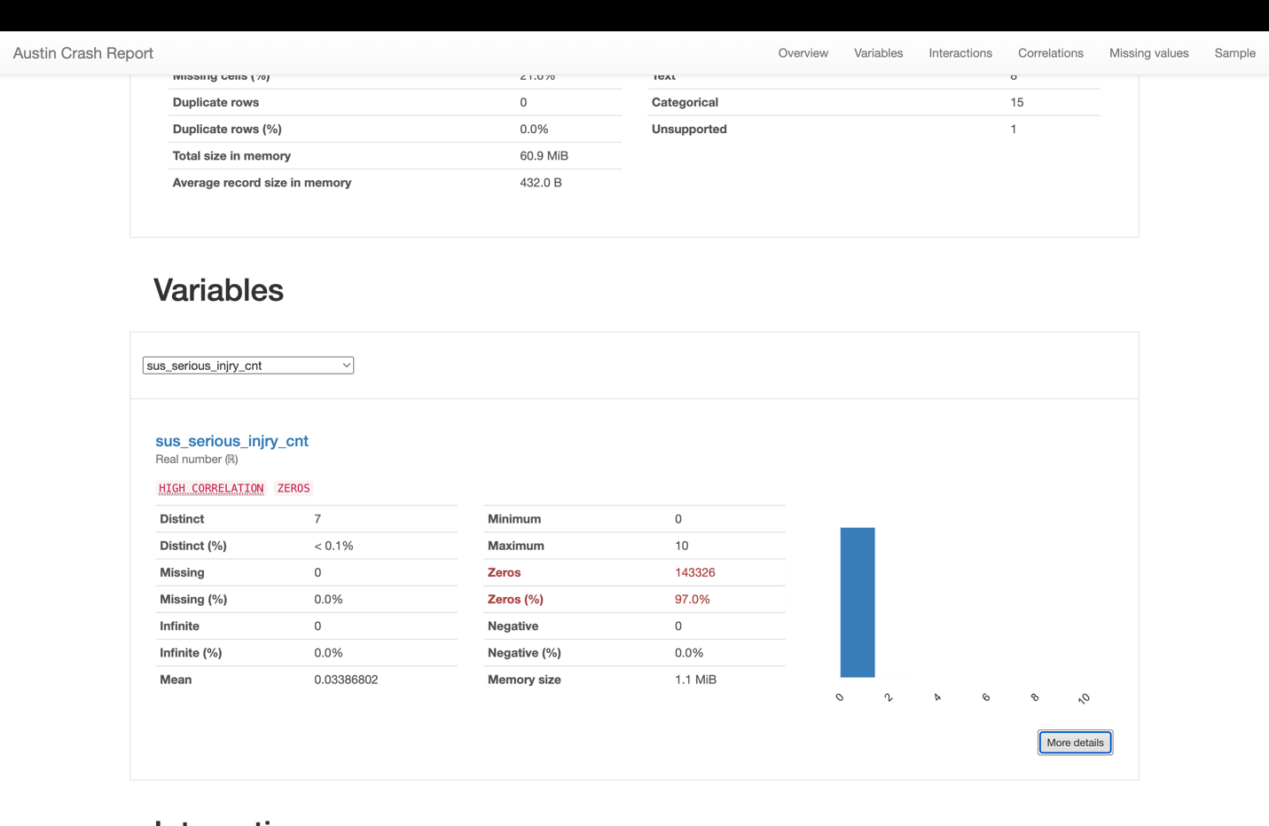

* **Distinct**: There are 7 distinct values present, which likely correspond to different counts of suspected serious injuries per crash.
* **Range**: The values range from 0 to 10, indicating that no crash resulted in more than 10 suspected serious injuries being recorded.
* **Zeros**: A significant majority, 97.0% of the entries, have a value of zero, suggesting that most crashes did not result in any suspected serious injuries.
* **Mean**: The average value is approximately 0.034, which is very close to zero, reinforcing the idea that serious injuries are rare in the data reported.
* **Data Completeness**: There are no missing values, which indicates that this variable is well-recorded across all crash reports.

**Nonincap_injry_cnt**

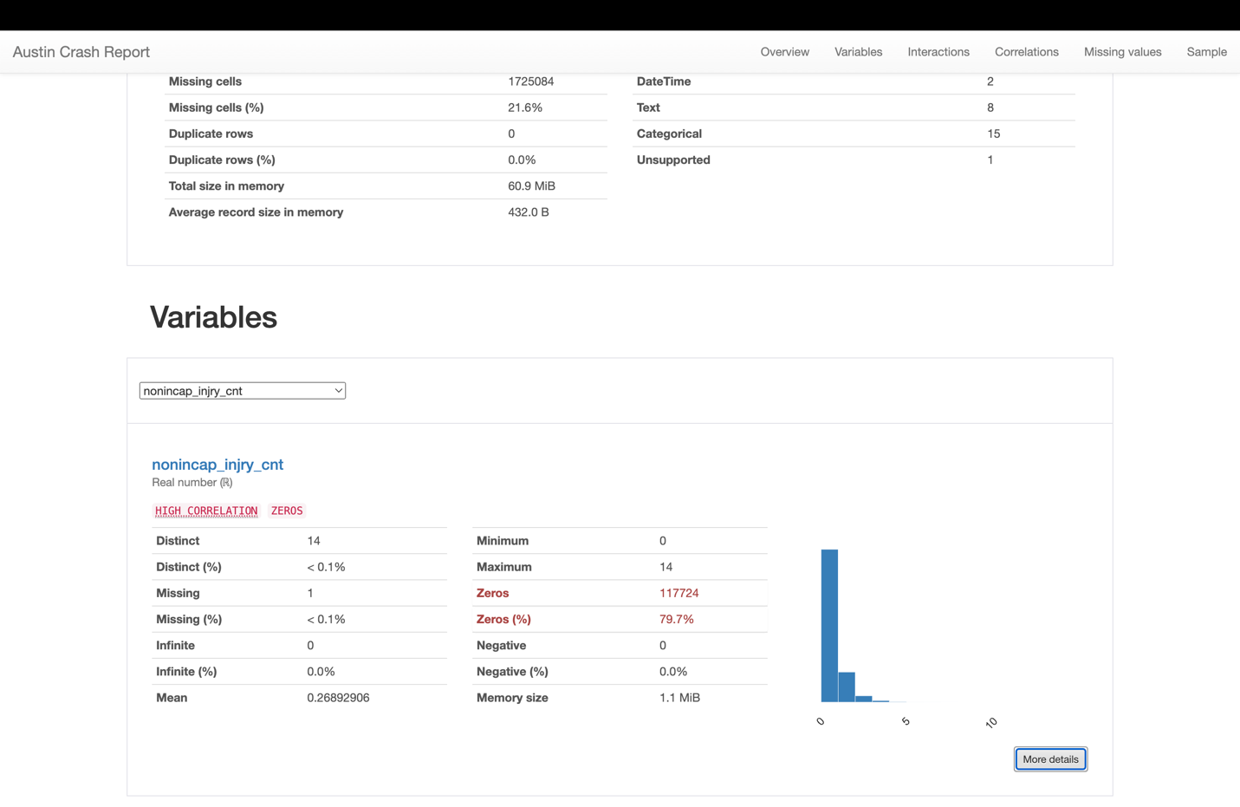

* **Distinct Values**: There are 14 distinct values, indicating that the dataset captures a range of non-incapacitating injuries from 0 to 14 per crash.
* **Zeros Predominance**: A vast majority, about 79.7%, of the records have a zero count for non-incapacitating injuries, suggesting most crashes did not result in injuries that were non-incapacitating.
* **Data Completeness**: Only one entry is missing for this variable, which is negligible in terms of percentage, showing that the data collection for this variable is highly complete.
* **Range of Data**: The variable ranges from 0 to 14, providing insights into the frequency and distribution of non-incapacitating injuries in crashes.
* **Mean Value**: The mean value is approximately 0.2689, indicating that on average, there are very few non-incapacitating injuries per crash.

Pos_injry_cnt

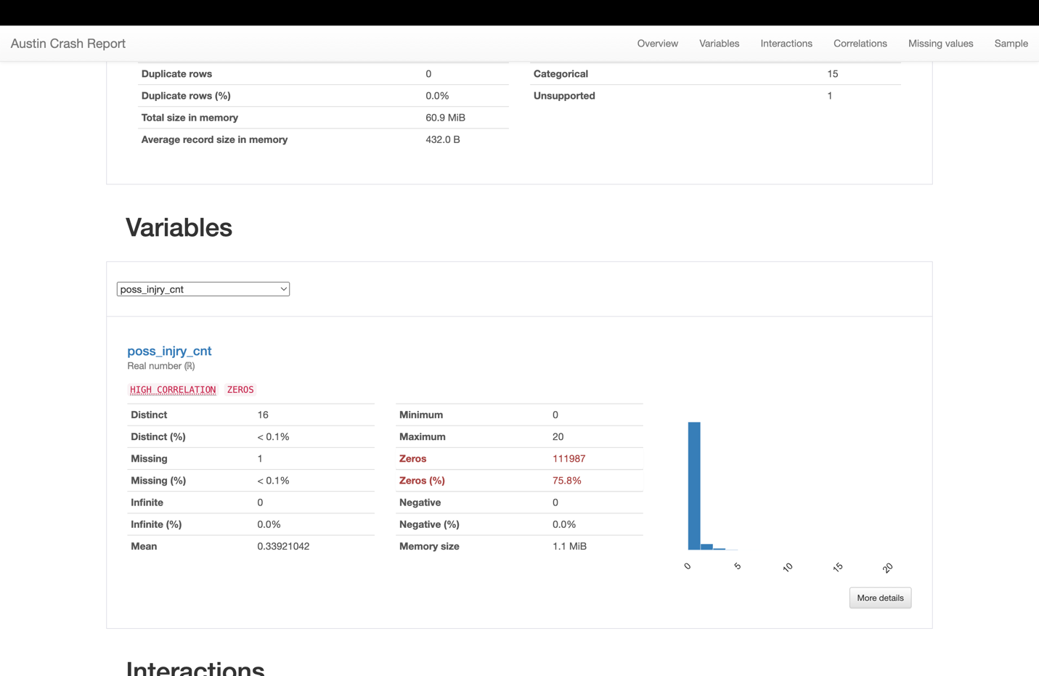

* **Distinct Values**: The data shows there are 16 distinct values for possible injuries, ranging from 0 to 20 per incident, indicating variability in the severity and outcomes of crashes.
* **Majority Non-Injuries**: The zeros account for 75.8% of the data, suggesting that most crash incidents did not result in injuries that were deemed "possible" at the time of the report.
* **Data Completeness**: The variable is nearly complete with only one entry missing, which is insignificant in terms of the dataset's size, thus ensuring reliability in the data presented.
* **Range and Mean**: The range from 0 to 20 with a mean of 0.3392 suggests that while most crashes do not result in possible injuries, those that do have a low average count.

**Non_injry_cnt**

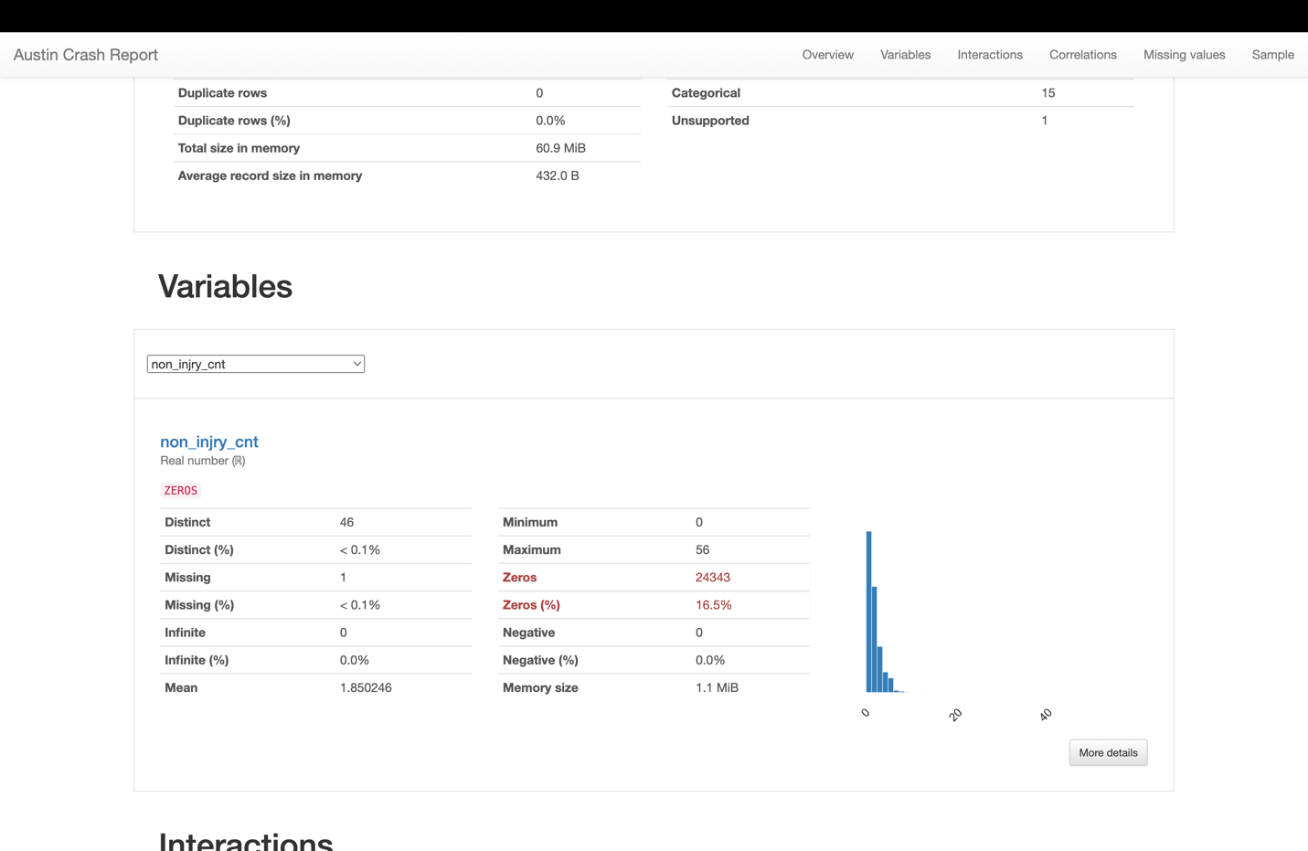

The non_injry_cnt variable in the Austin Crash Report likely represents the count of non-injured individuals involved in crash incidents:

* **Distinct Values**: There are 46 distinct counts of non-injured individuals, which indicates a variety of crash outcomes in terms of non-injuries.
* **Non-Injuries Presence**: With zeros at 16.5%, this suggests that a significant portion of crashes resulted in no non-injuries being reported.
* **Data Completeness**: Only one entry is missing, indicating a nearly complete data set for this variable, which allows for accurate analysis of non-injuries in crashes.
* **Range and Mean**: The range of non-injured counts from 0 to 56, and a mean of 1.850246 suggests that there are typically one or two non-injured individuals reported per crash incident.

**Unkn_injry_cnt**

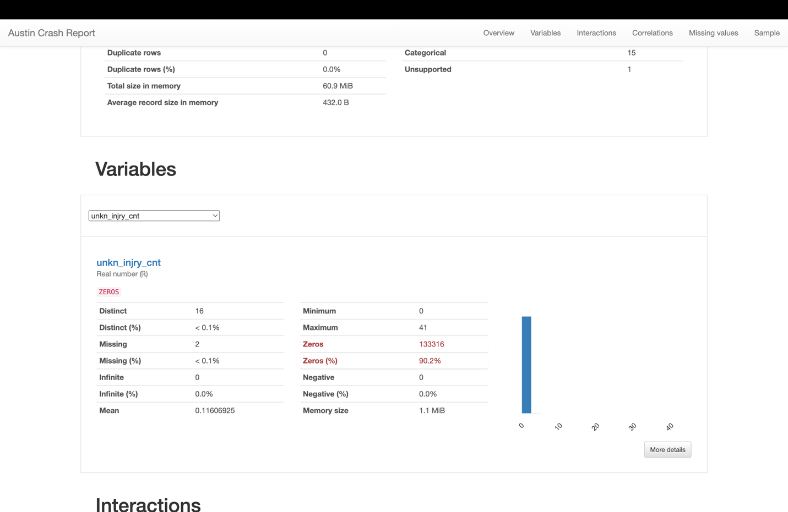

* **Distinct Values**: There are 16 distinct values, indicating that there were up to 41 people in a single crash whose injury status was not known, showing variability in the recording of this data.
* **Majority Without Unknown Injury Status**: 90.2% of the records have a zero count for unknown injury, suggesting that for most crashes, the injury status of individuals is known.
* **Data Completeness**: With only two missing entries, the data is nearly complete, providing a reliable base for statistical analysis.
* **Average**: The mean value is approximately 0.116, which is quite low and indicates that, on average, there are very few unknown injury statuses per crash.

**Tot_injry_cnt**

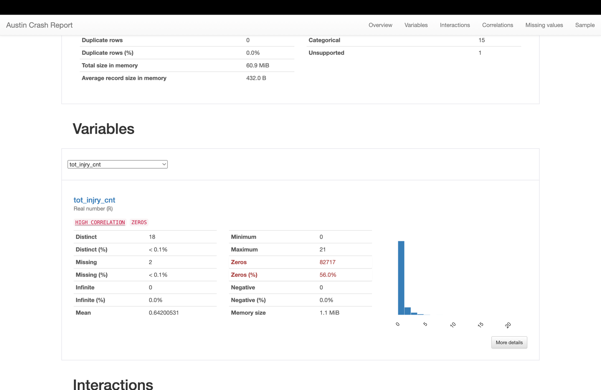

* **Distinct Values**: There are 18 distinct values in this variable, which likely correspond to the number of injuries ranging from 0 to some maximum number in the dataset.
* **Data Completeness**: There are only 2 missing entries for this variable, indicating that the data is nearly complete.
* **Range**: The values range from 0 to a maximum of 21 injuries in a single crash.
* **Zeros**: A significant proportion of the entries, 56.0%, have a zero count for this variable, suggesting that many crashes did not result in any injuries.
* **Average**: The mean injury count is approximately 0.642, indicating that, on average, there are less than one injury per crash.
* **Data Distribution**: The histogram shows that the distribution is heavily skewed towards zero, which is common in such datasets where many crashes result in no injuries.

**Death_cnt**

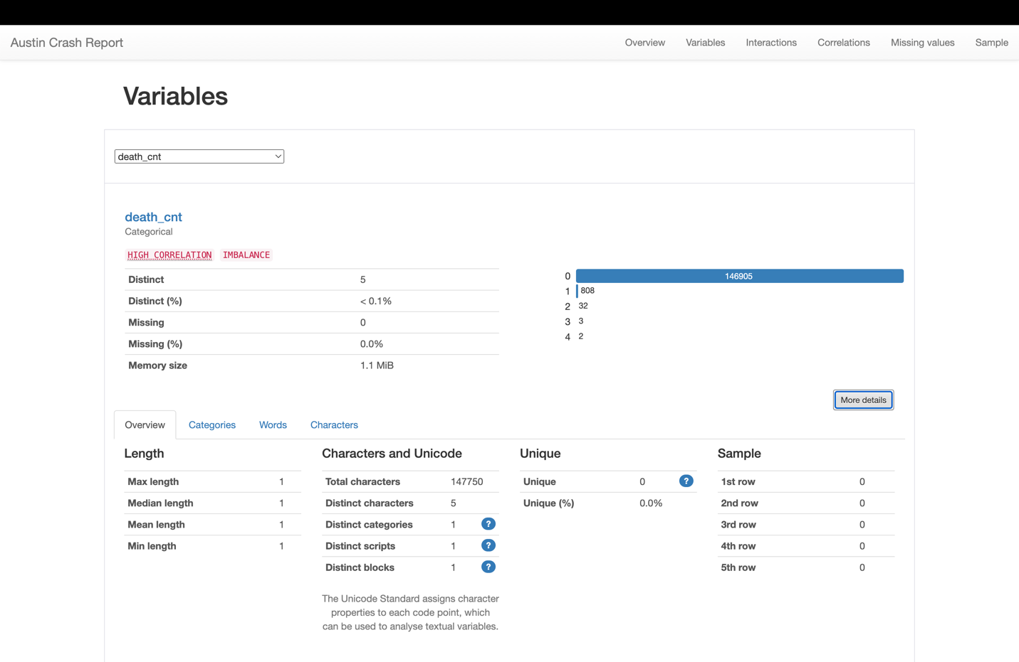

* **Data Type**: It is categorized as a categorical variable, which means that death counts are treated as distinct categories rather than numerical values. This could be because the counts are low and discrete.
* **Distinct Values**: There are 5 distinct categories, indicating the number of fatalities in an accident ranges from 0 to 4.
* **Data Completeness**: There are no missing entries for this variable, which implies that the dataset has a fatality count for every crash record.

**contrib_factr_p1_id****:**

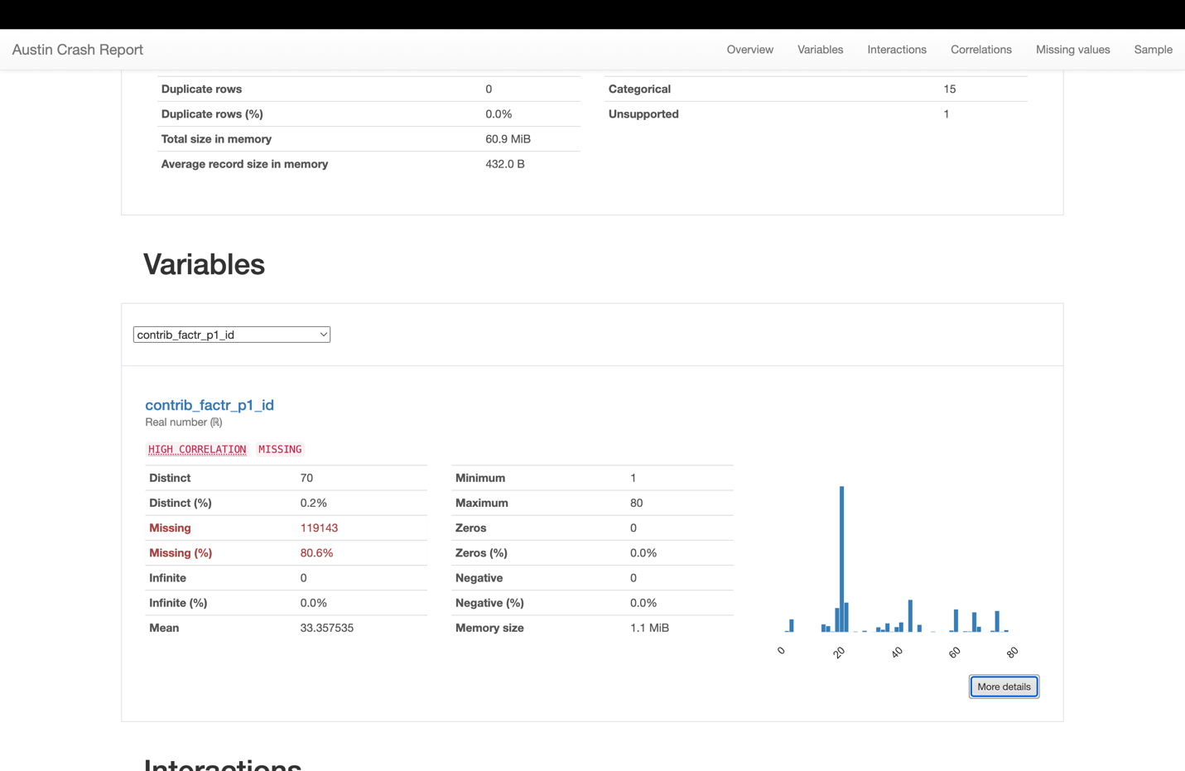

* **Data Type**: The variable is numeric, which suggests that contributing factors are coded as integers for analytical purposes.
* **Distinct Values**: There are 70 distinct values, indicating a wide range of contributing factors that have been identified and categorized.
* **Data Range**: Values range from 1 to 80, which might correspond to a predefined list of factors contributing to the crashes.
* **Missing Data**: A significant amount of data is missing, with 80.6% missing values. This suggests that for the majority of crashes, the primary contributing factor was not recorded or is unknown.
* **Data Distribution**: The histogram shows a non-uniform distribution of the different contributing factors, with certain IDs being more common than others.

contrib_factr_p2_id

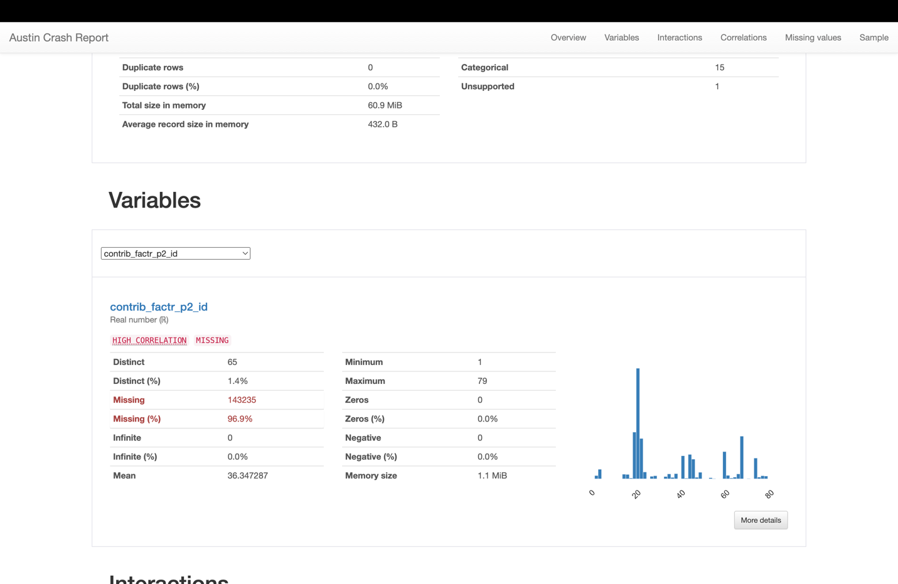

* **Variable Type**: Real number, though it is treated as a categorical variable because it represents distinct categories of contributing factors to crashes.
* **Distinct Values**: There are 70 unique identifiers, suggesting a wide range of contributing factors being considered.
* **Range**: The identifiers range from 1 to 80, which could indicate specific codes assigned to different contributing factors.
* **Missing Data**: A significant proportion of the data, 80.6%, is missing for this variable. This could have implications for data analysis, as a large amount of information about contributing factors is not available.
* **Data Distribution**: The histogram provided shows the frequency of each identifier, with some contributing factors being more prevalent than others.

units_involved

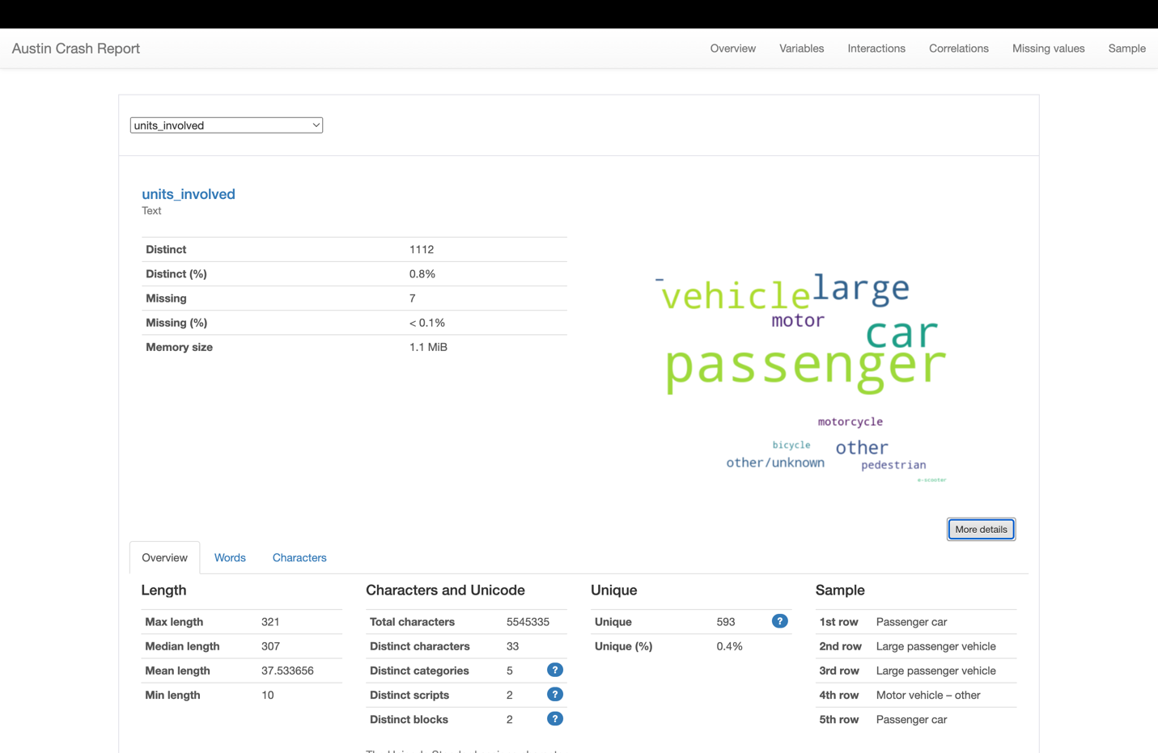

* **Data Type**: Numeric. The data consists of numerical values, likely integers, which are used to encode contributing factors to crashes for analysis.
* **Distinct Values**: With 70 distinct numerical values, the data covers a broad spectrum of potential contributing factors to crashes.
* **Data Range**: The numerical range of contributing factors is between 1 and 80, suggesting that there is a standardized list or categorization of contributing factors that have been used to code the data.
* **Missing Data**: A notably high percentage (80.6%) of data is missing for the contributing factors. This is significant because it means for the majority of the reported crashes, the contributing factor has not been documented or is unknown, which could impact the reliability and conclusiveness of any analysis performed on this dataset.
* **Data Distribution**: The data's distribution is described as non-uniform, with some contributing factor codes being more frequently reported than others. This non-uniformity indicates that some factors are more prevalent as crash contributors.

atd_mode_category_metadata

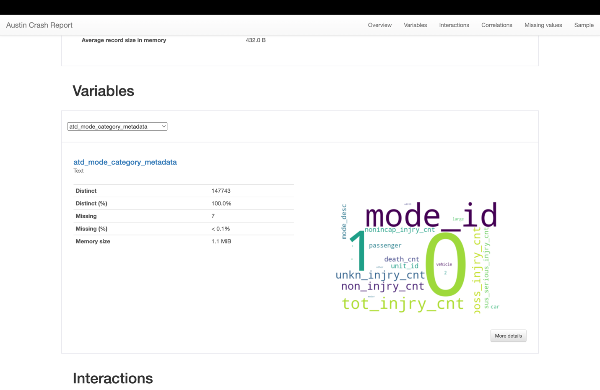

**Variable Overview**: The variable atd_mode_category_metadata is a text-type variable and has the following properties:

* **Distinct**: There are 1,477,743 distinct entries for this variable, which interestingly constitutes 100% of the data. This suggests that each entry in this part of the dataset is unique.
* **Missing**: There are 7 missing entries, which is a negligible fraction of the data (less than 0.1%).

pedestrian_fl

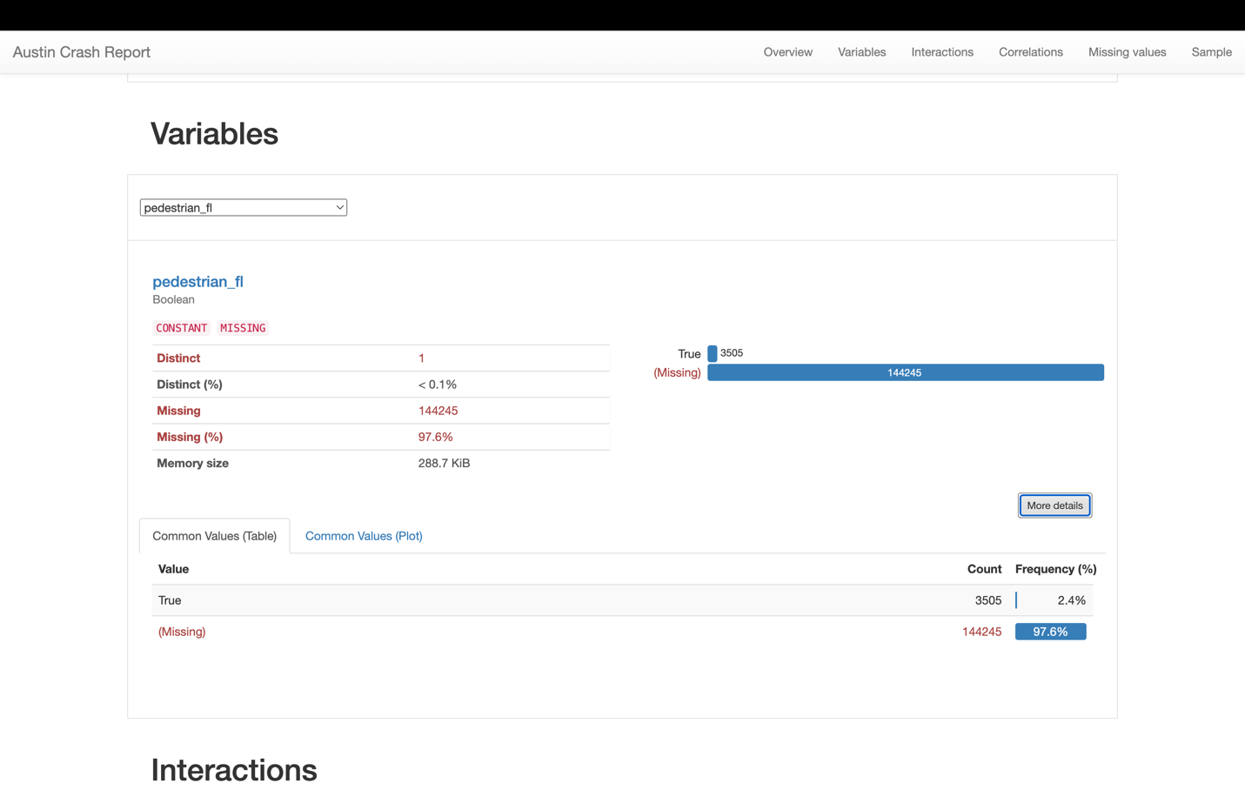

**Data Completeness**:

* **Distinct**: There's only 1 distinct entry that's been identified, suggesting that either the value True or False is not present in the data, or it might be indicating the presence of a single constant value aside from the missing data.
* **Missing**: A very high number of entries are missing for this variable, with 144,245 cases (97.6% of the data), which leaves the data largely incomplete.

motor_vehicle_fl

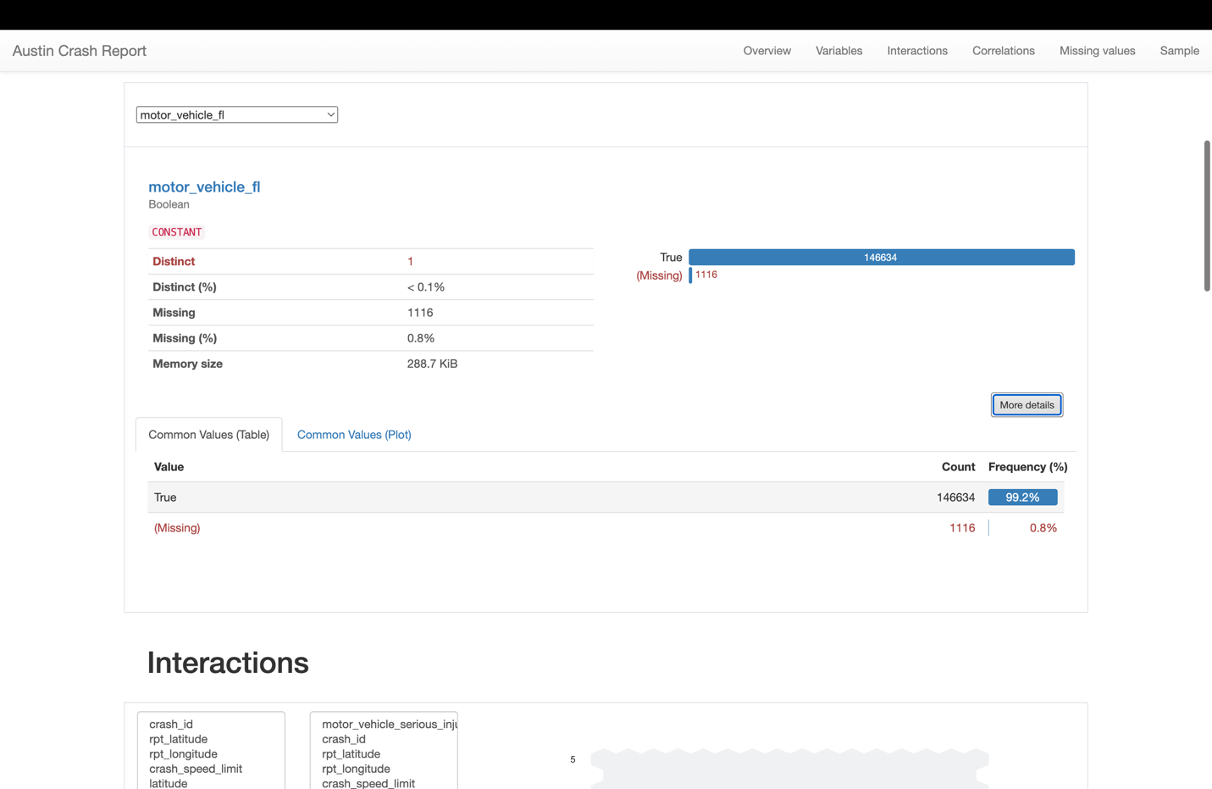

* **Constant**: This suggests that there is very little variation in the values for this variable across the dataset.
* **Distinct Values**: There is only 1 distinct value across the dataset, indicating that almost all records have the same value for this field.
* **Missing Data**: There are 1,116 entries missing this data, which is 0.8% of the data. This implies a high rate of data completeness for this variable.

motorcycle_fl

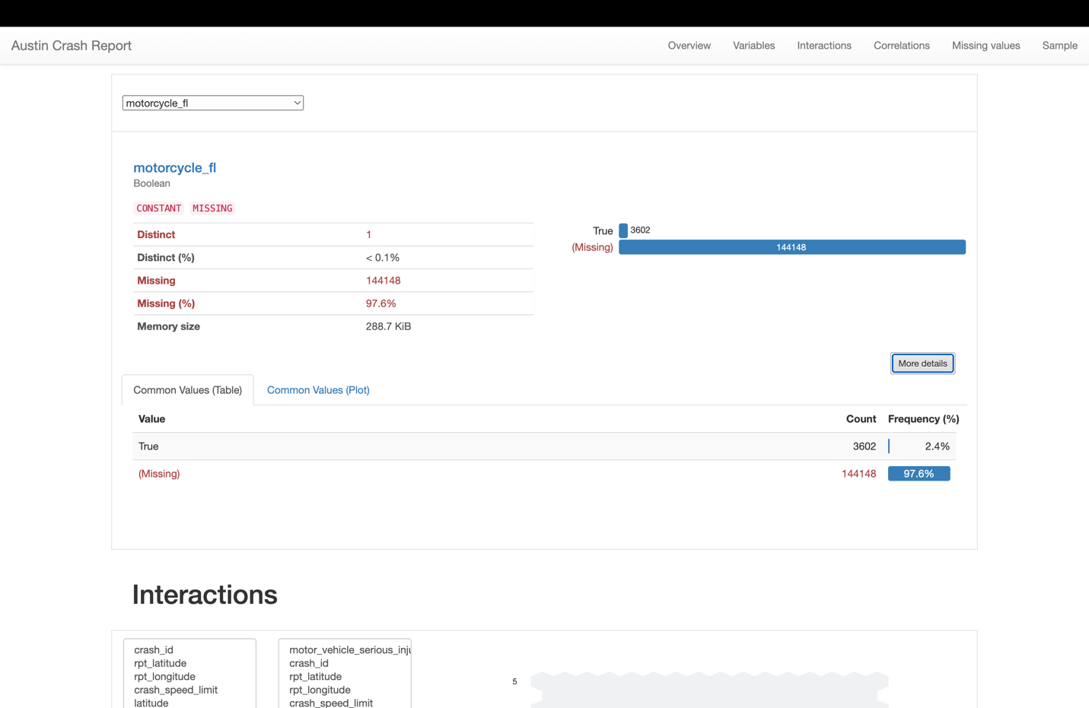

* **Data Consistency**: The variable is mostly missing across the dataset, which is indicated by the word "CONSTANT" under the missing category.
* **Distinct Entries**: There is only one distinct value recorded in the dataset for this variable, which is less than 0.1% of the entries.
* **Missing Data**: A very large number of the entries, 144,148 to be exact, do not have data for motorcycle_fl, which is 97.6% of the dataset. This high percentage of missing data implies that for most of the records, whether a motorcycle was involved is not known.

bicycle_fl

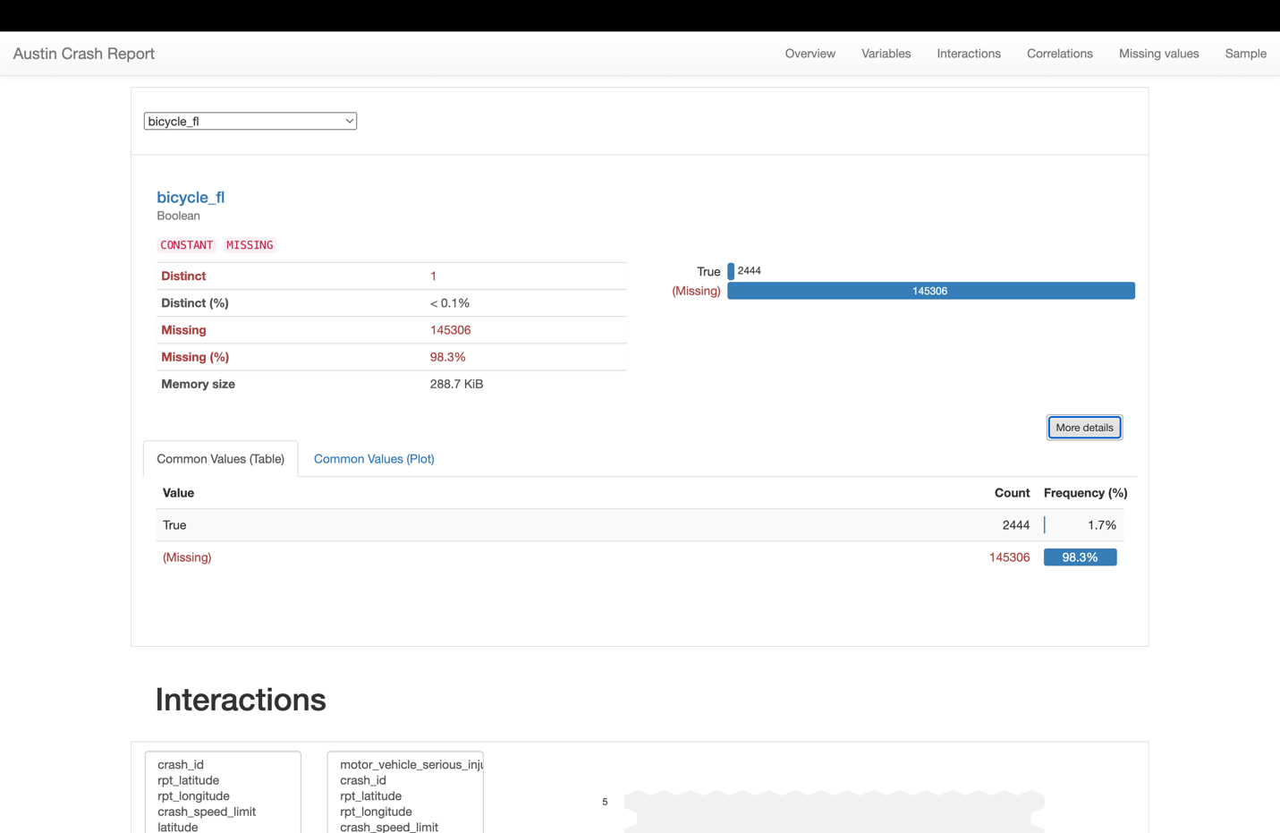

* **Data Completeness**:
  1. **Distinct Entries**: There is only one distinct entry in the dataset, likely True, since Boolean types typically have two possible values (True or False).
  2. **Missing Data**: A significant portion of data, 145,306 entries or 98.3%, is missing for this variable, indicating that in most of the crash reports, information about bicycle involvement is not recorded.
* **Memory Usage**:
  1. The bicycle_fl variable uses 288.7 KiB of memory.
* **Value Counts**:
  1. The bar graph shows that there are 2,444 instances where the value is True, representing 1.7% of the dataset.

other_fl

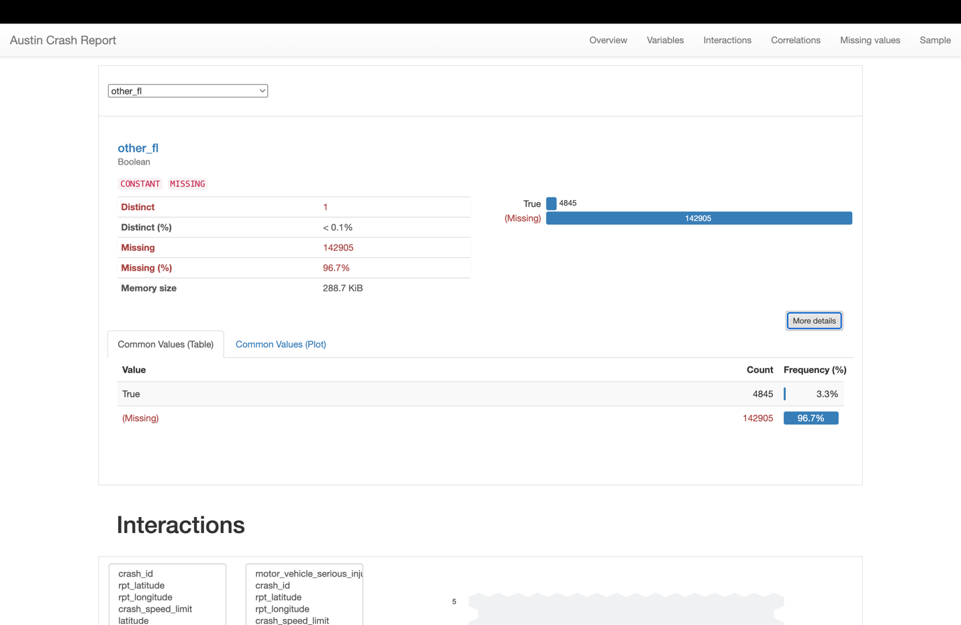

* **Variable Information**: bicycle_fl is identified as a Boolean variable, which is typically used to represent binary options, such as yes/no or true/false.
* **Data Summary**:
  1. **Distinct**: There is only 1 distinct entry, likely "True", since Boolean data types have two possible values and there's a separate count for missing data.
  2. **Missing**: A significant amount, 145,306 entries or 98.3% of the data, is missing for this variable.
  3. **Memory Size**: The variable consumes 288.7 KiB in memory.
* **Data Values**:
  1. There are 2,444 instances where the value is "True", which represents only 1.7% of the dataset.

**Other:**

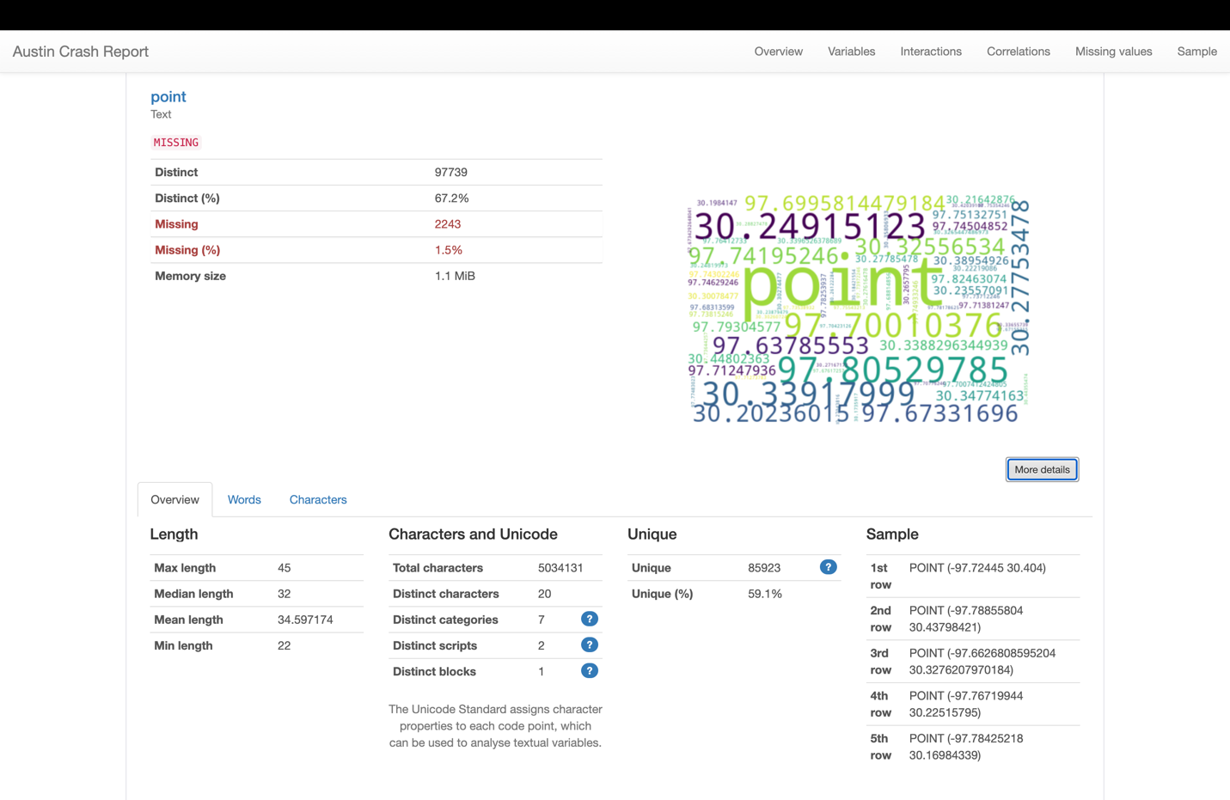

* **Data Summary for** point:
  1. **Distinct**: 97,739 distinct entries exist, making up 67.2% of the data.
  2. **Missing**: There are 2,243 missing entries, which account for 1.5% of the data.
  3. **Memory Size**: The data for this variable takes up 1.1 MiB.
* **Data Length**:
  1. **Max Length**: The longest entry is 45 characters.
  2. **Median Length**: The median length is 32 characters.
  3. **Mean Length**: The average entry is approximately 34.6 characters long.
  4. **Min Length**: The shortest entry is 22 characters.

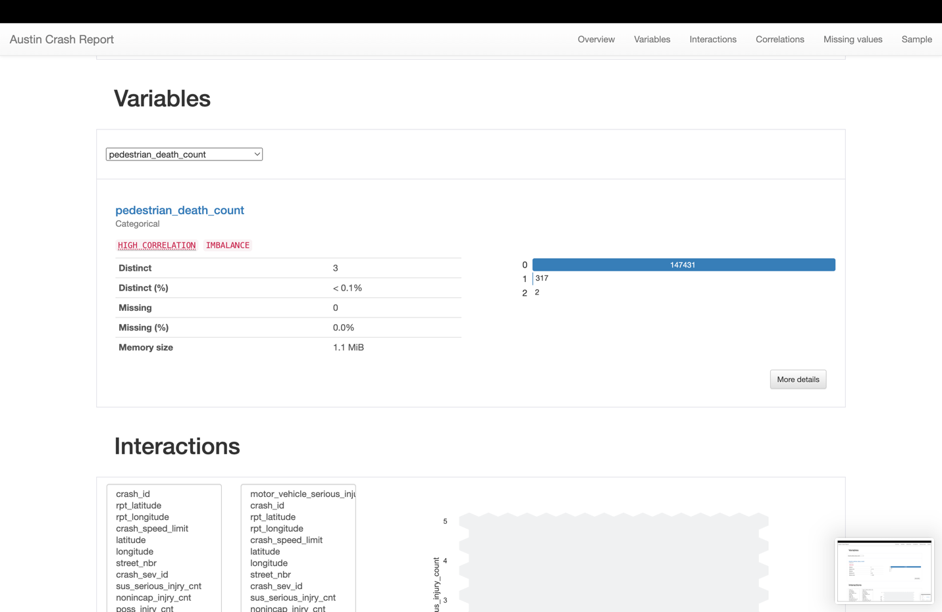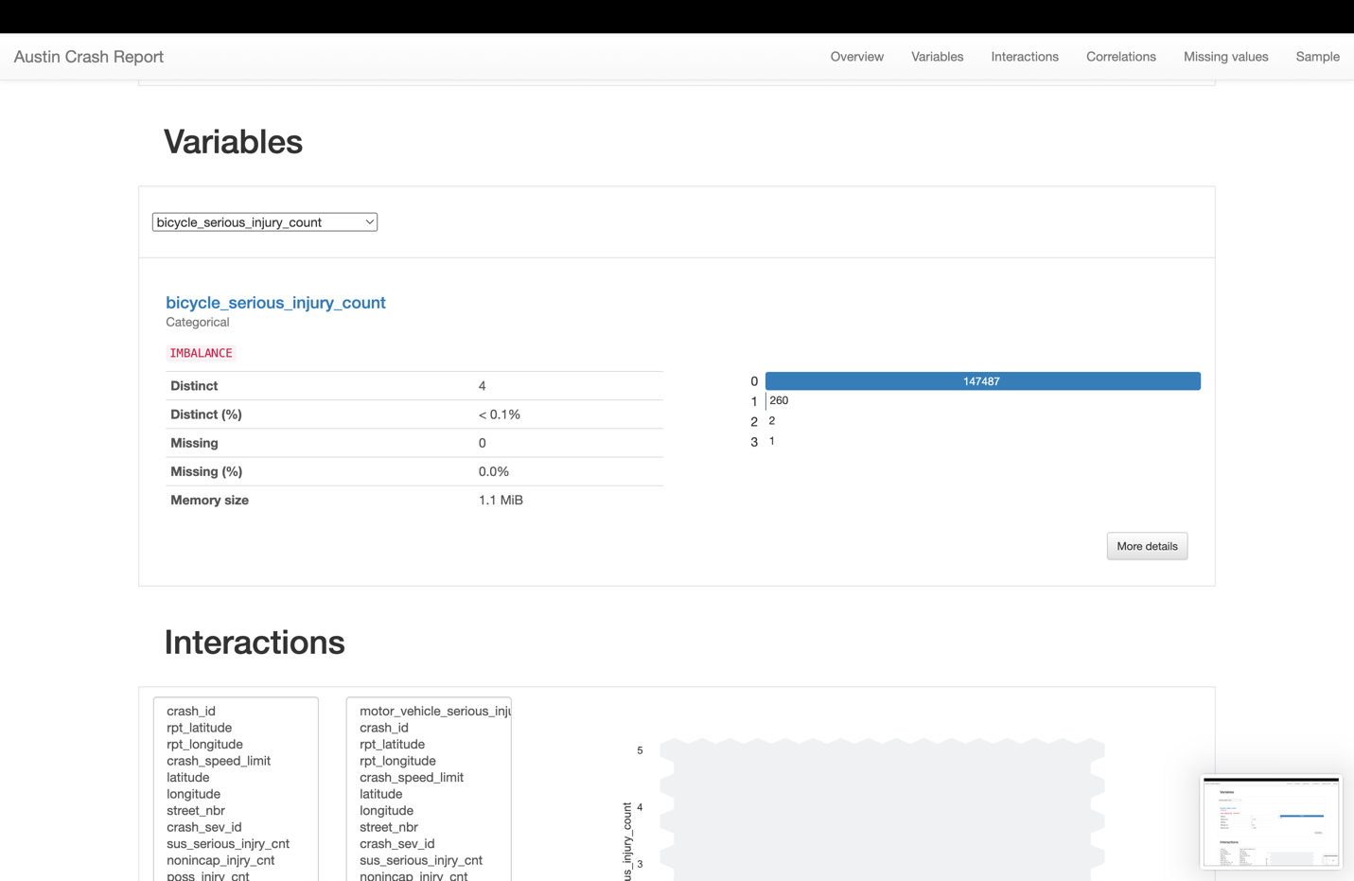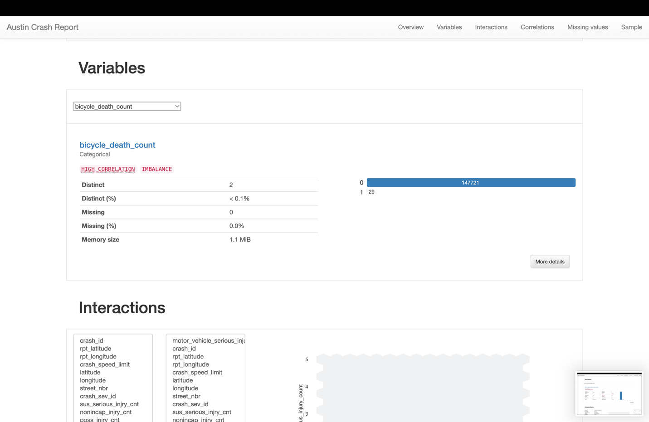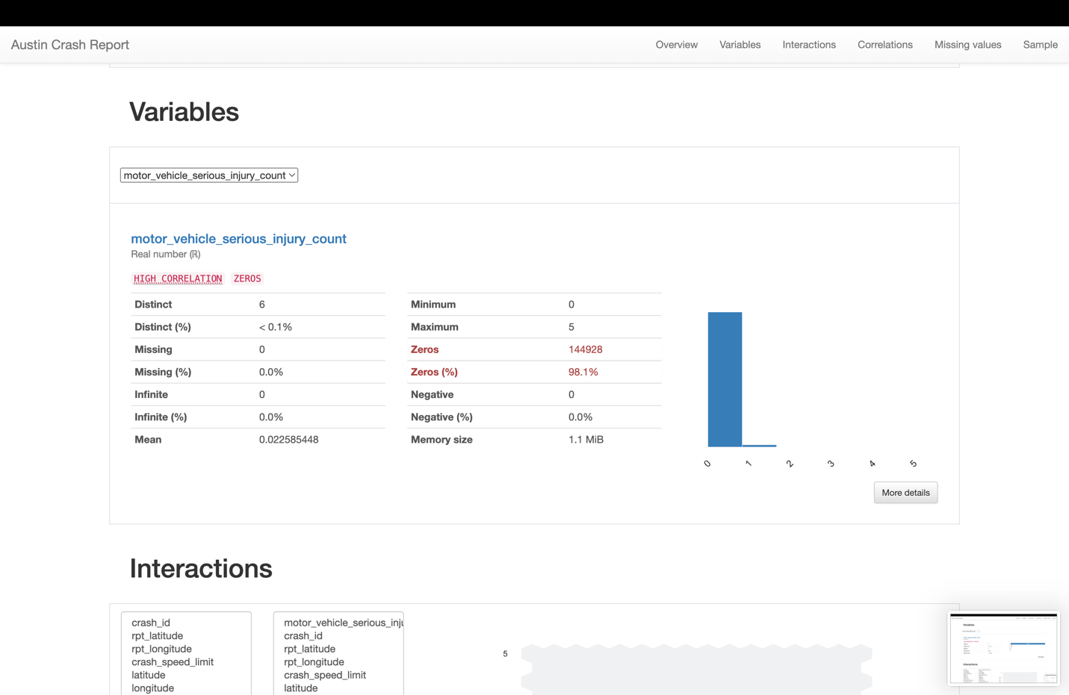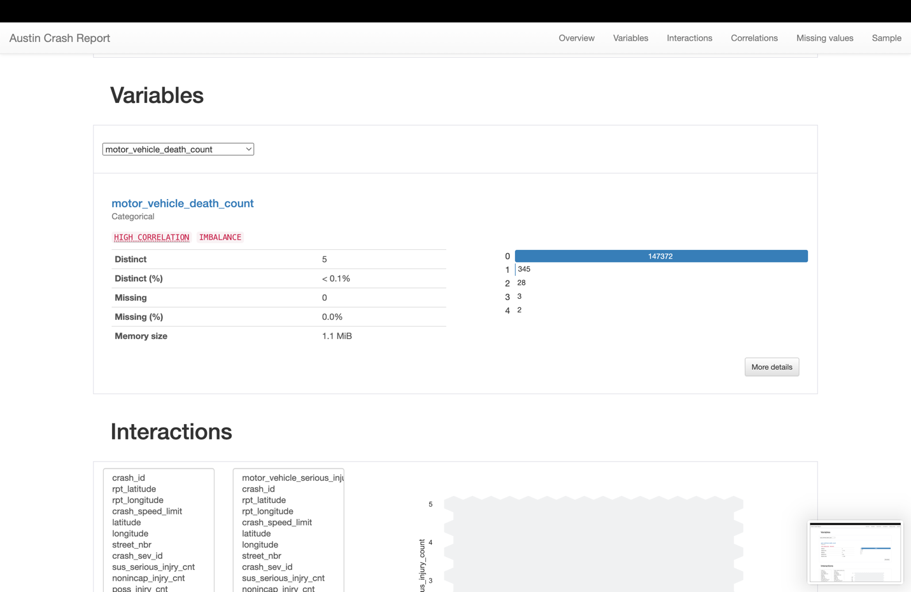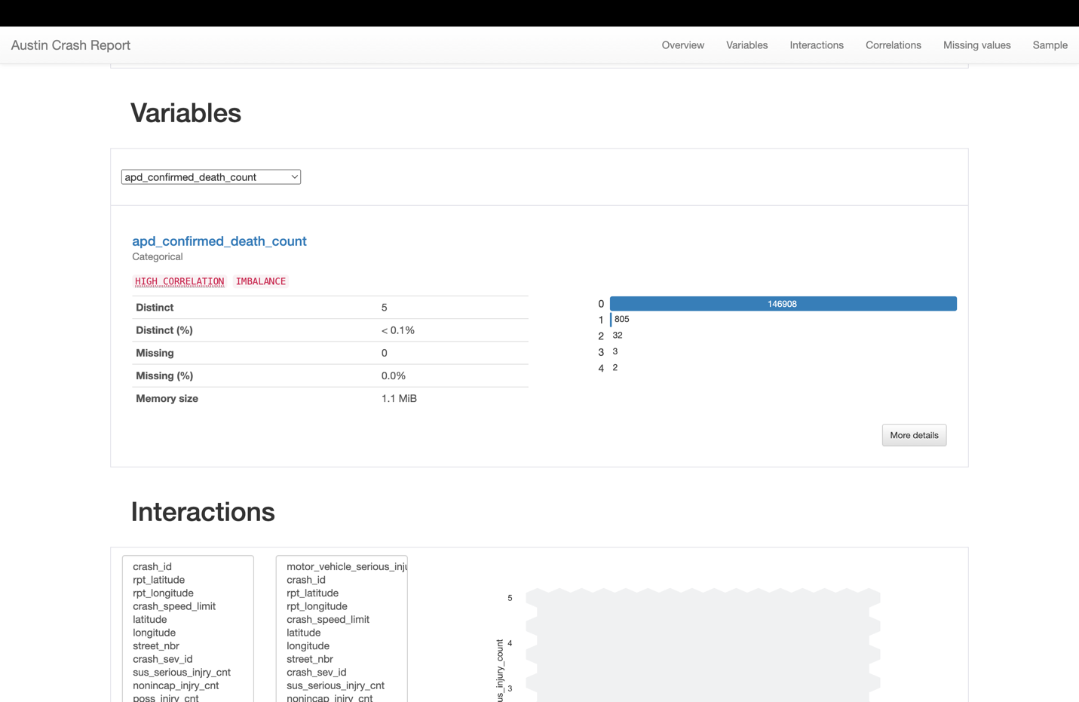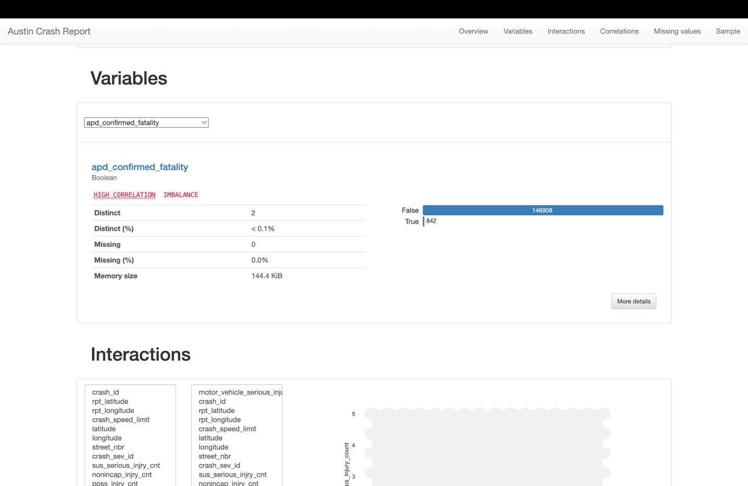

* **Pedestrian Death Count**:
  1. Categorical variable with 3 distinct values.
  2. There are 0 missing entries, so the data is complete.
  3. The memory size for this variable is 1.1 MiB.
* **Bicycle Serious Injury Count**:
  1. Categorical variable with 4 distinct values.
  2. There are 0 missing entries.
  3. The memory size is 1.1 MiB.
* **Motor Vehicle Serious Injury Count**:
  1. Real number variable with 6 distinct values.
  2. Zero missing entries.
  3. The memory size is 1.1 MiB.
* **Motor Vehicle Death Count**:
  1. Categorical variable with 5 distinct values.
  2. No missing entries.
  3. Memory size is 1.1 MiB.
* **APD Confirmed Death Count**:
  1. Categorical variable with 5 distinct values.
  2. There are 0 missing entries.
  3. Memory size for this variable is 1.1 MiB.
* **APD Confirmed Fatality**:
  1. Boolean variable with 2 distinct values (True or False).
  2. No missing entries.
  3. The memory size is 144.4 KiB.

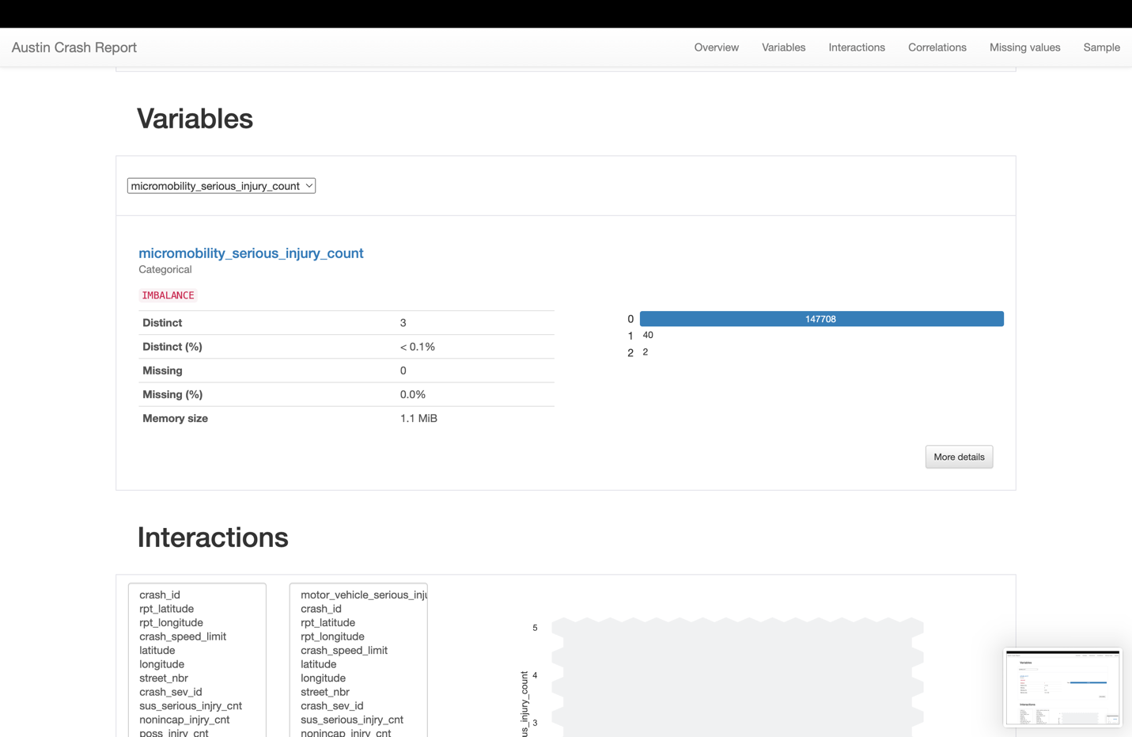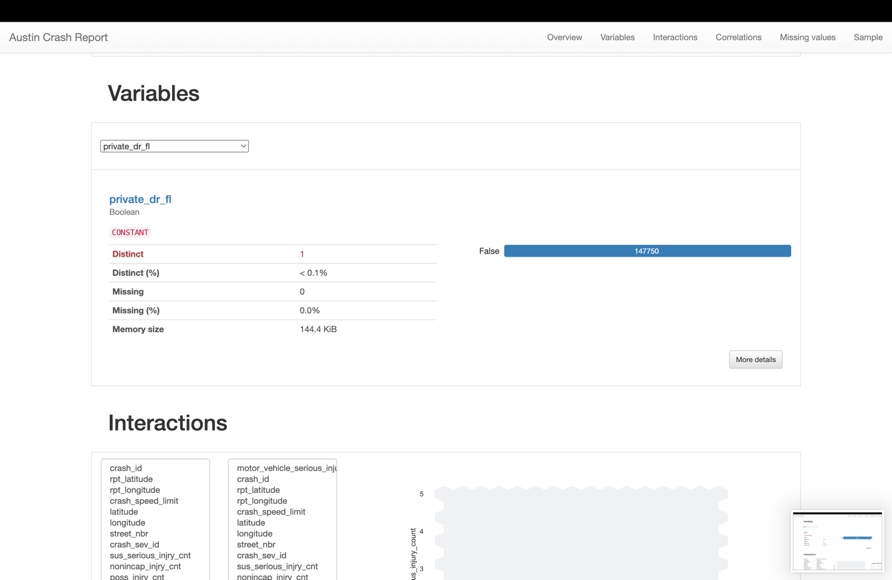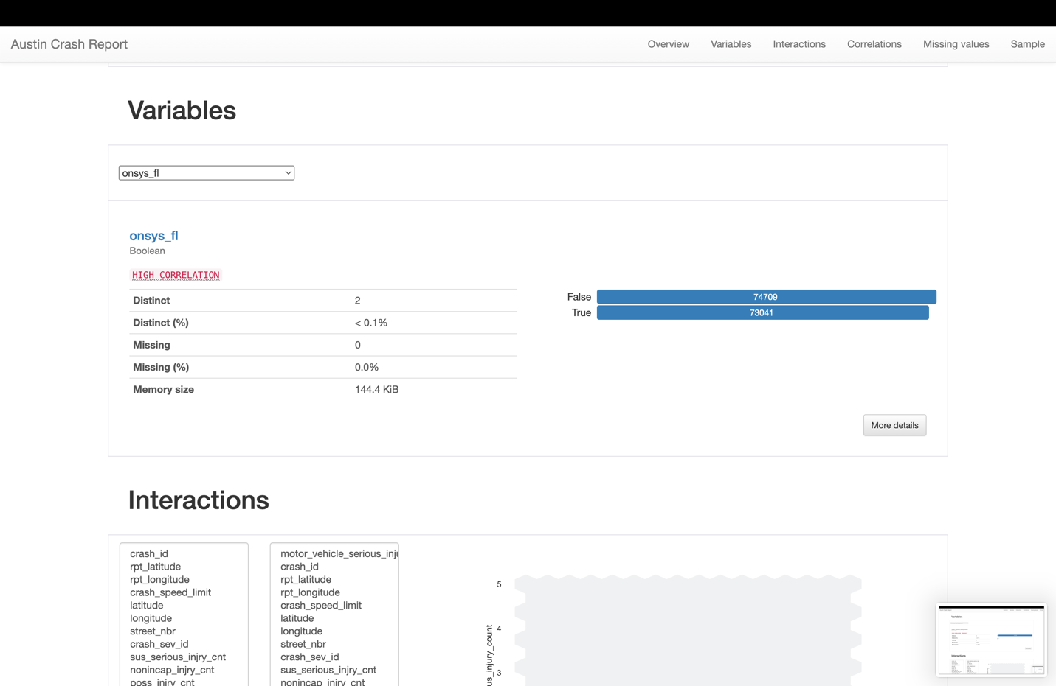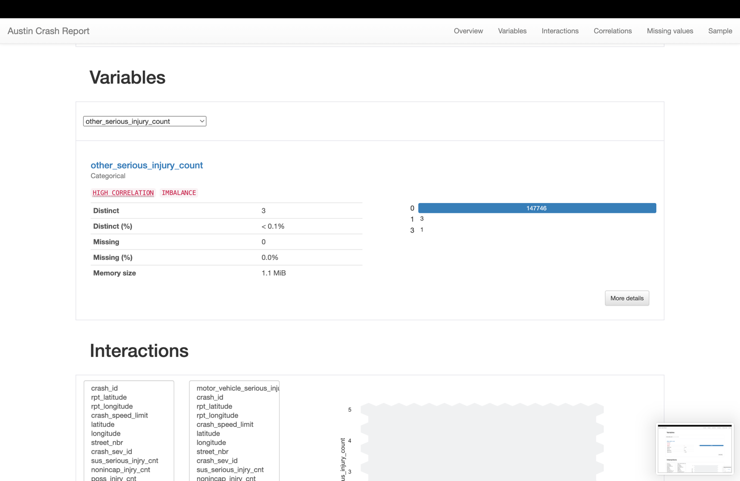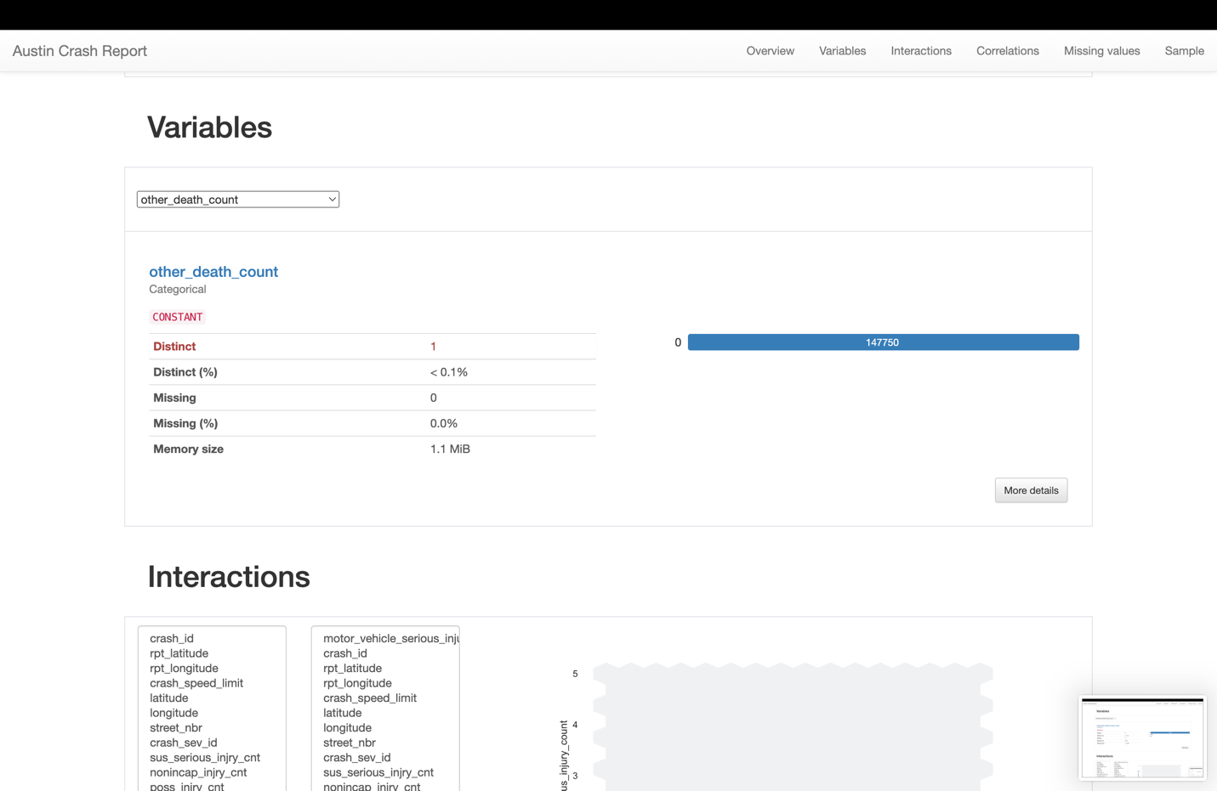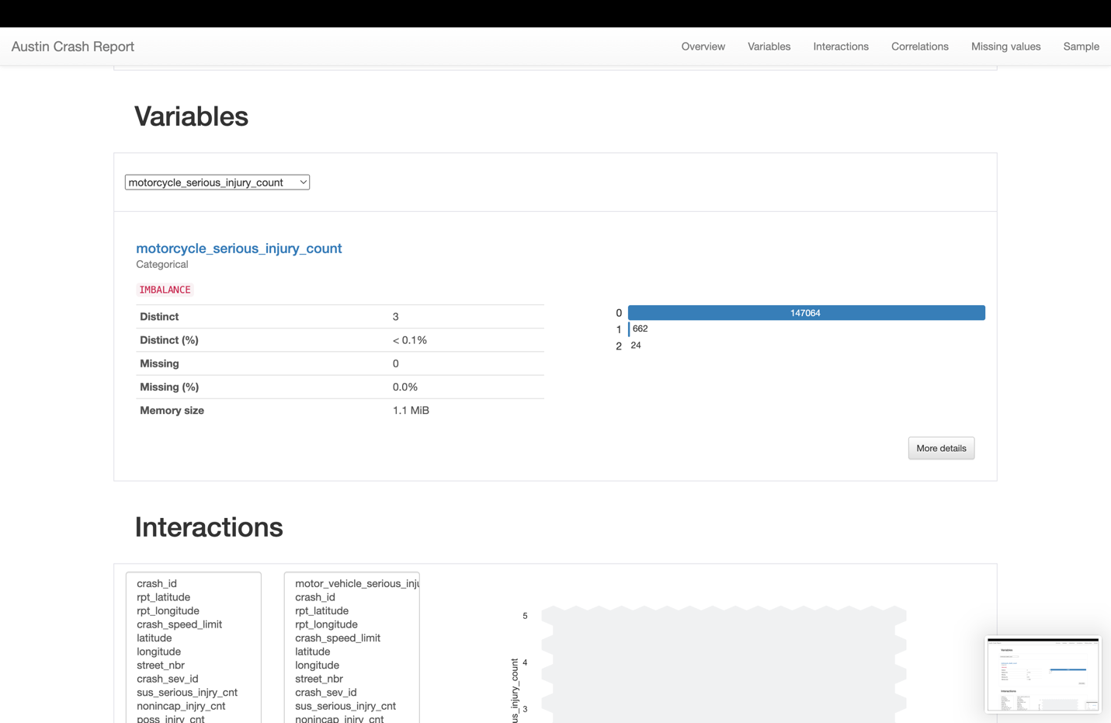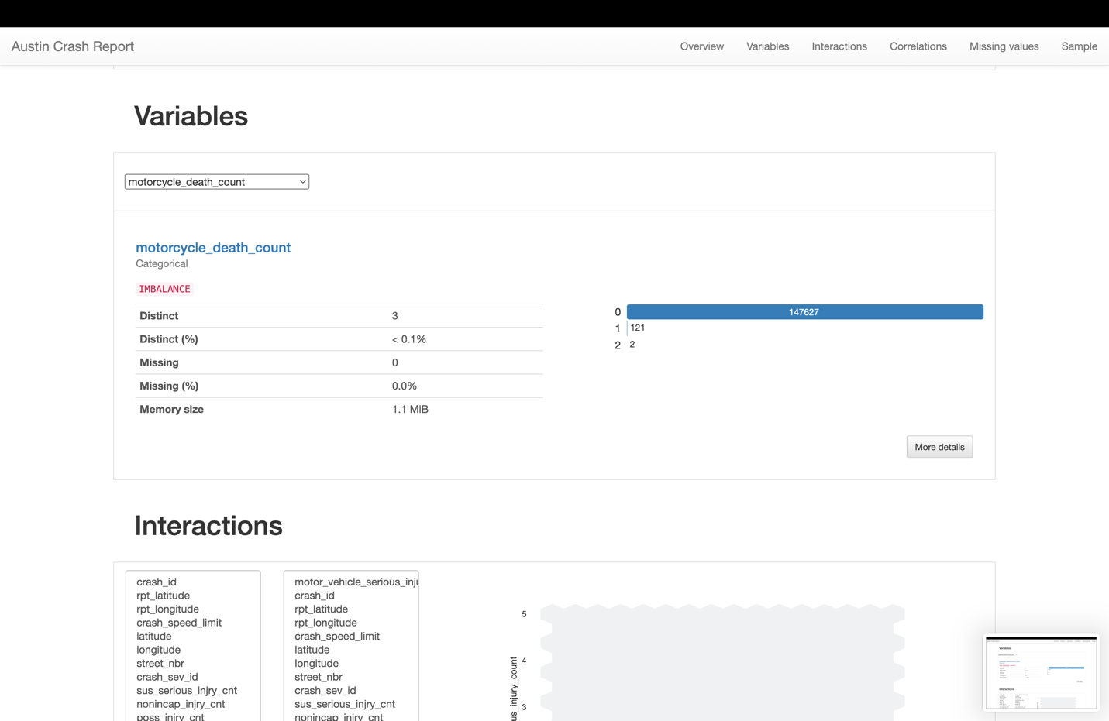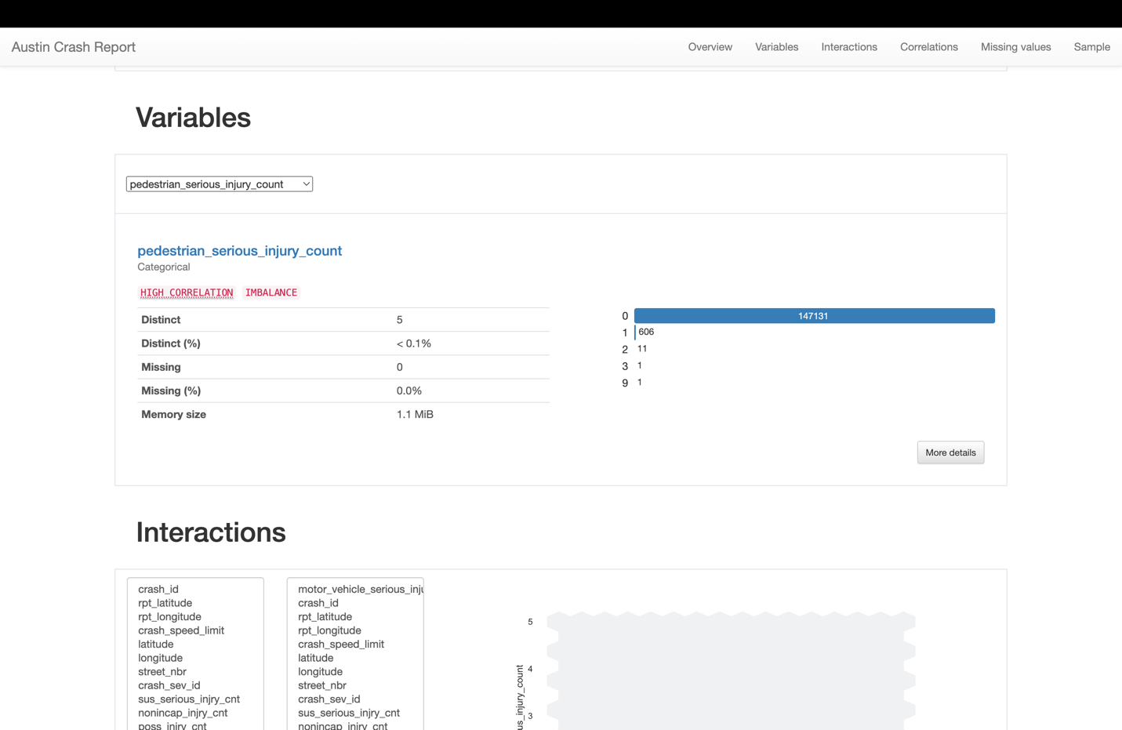

**micromobility_serious_injury_count**:

* 1. This variable appears to be categorical and records the count of serious injuries associated with micromobility devices.
  2. There are 3 distinct values: 0 occurrences (147708 times), 1 occurrence (40 times), and 2 occurrences (2 times).
  3. The data does not contain any missing values, and the memory size for this variable is 1.1 MiB.

**private_dr_fl**:

* 1. This is a boolean variable, likely indicating whether a certain condition is true or false, possibly related to a private drive or driveway involvement in an incident.
  2. There is only 1 distinct value (False) occurring 147750 times, suggesting that this variable is constant across the dataset.

**onsys_fl**:

* 1. Another boolean variable, possibly indicating if an incident occurred on a system or network.
  2. There are 2 distinct values: False (74709 times) and True (73041 times), with no missing values.

**other_serious_injury_count**:

* 1. This categorical variable seems to be tracking the count of serious injuries not covered by other specific categories.
  2. There are 3 distinct values: 0 (147746 times), 1 (3 times), and 3 (1 time), again with no missing data.

**other_death_count**:

* 1. A categorical variable that records the number of deaths not included in other categories.
  2. Only 1 distinct value is present, which is 0, occurring 147750 times.

**motorcycle_serious_injury_count**:

* 1. This variable tracks serious injuries involving motorcycles.
  2. It has 3 distinct values: 0 (147064 times), 1 (662 times), and 2 (24 times).

**motorcycle_death_count**:

* 1. Records the number of fatalities involving motorcycles.
  2. 3 distinct values are observed: 0 (147627 times), 1 (121 times), and 2 (2 times).

**pedestrian_serious_injury_count**:

* 1. This variable accounts for serious injuries to pedestrians.
  2. There are 5 distinct values with varying occurrences: 0 (147131 times), 1 (606 times), 2 (11 times), 3 (1 time), and 9 (1 time).

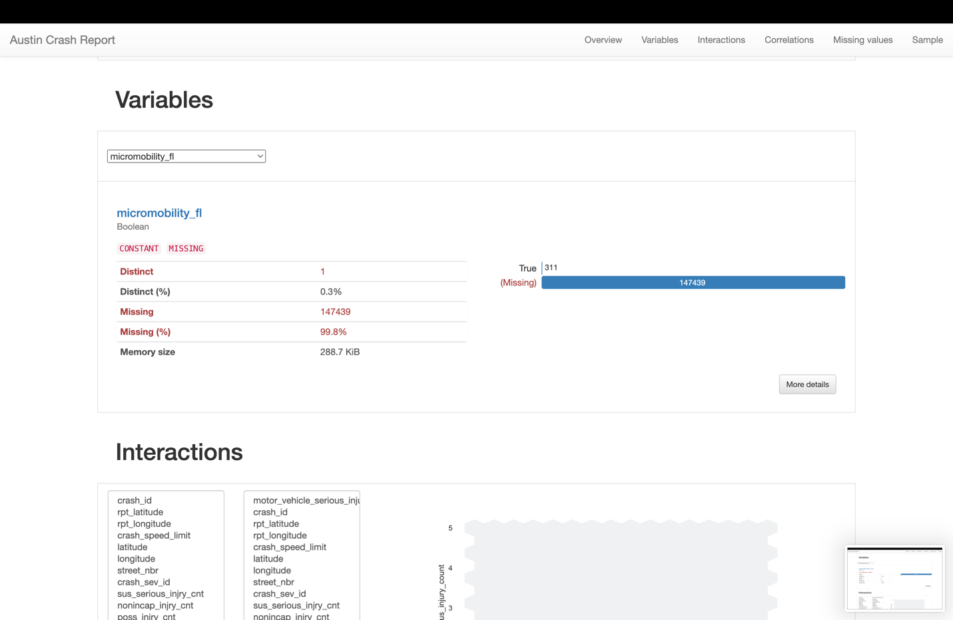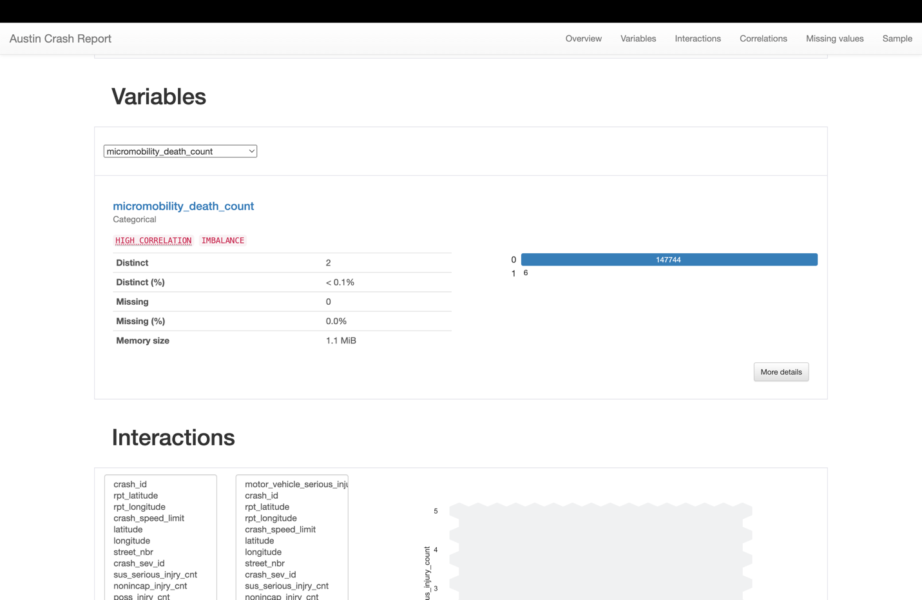

**Micromobility Flag (micromobility_fl):**

* 1. This is a Boolean variable, likely indicating whether a crash report involves a micromobility device (like a scooter or bike-share bicycle).
  2. It shows a high rate of missing data (99.8%), with 147,439 missing entries out of the total, suggesting this variable might not be widely applicable or recorded across the dataset.
  3. There are only 311 entries marked as 'True', which may be cases where a micromobility device was involved.

**Micromobility Death Count (micromobility_death_count):**

* 1. This categorical variable tracks the count of deaths associated with micromobility devices in crash incidents.
  2. The variable has an imbalance, with most cases reporting 0 deaths (147,744 cases), while a smaller number reports 1 death (6 cases). There are no cases with more than one death recorded for this variable.
  3. The data for this variable does not appear to have missing values, which indicates that this count has been reliably recorded across the dataset.